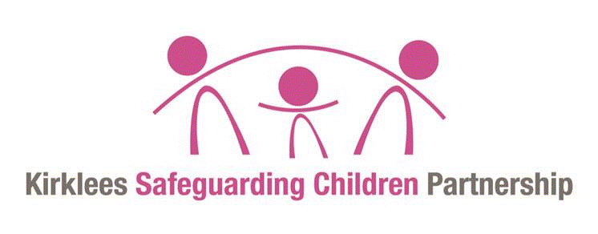

Referral Form of Serious Incident Notification

Working Together 2018 provides clear criteria in Chapter 4 about when the KSCP should conduct a Local Child Safeguarding Practice Review. KSCP partner agencies should ensure that Serious Incident notifications which may meet the criteria for a Local Child Safeguarding Practice Review Panel, or other type of learning/review, are brought to the attention of the Kirklees Safeguarding Children Partnership.

Professionals wishing to notify a case to the Children Social Care and KSCP should submit the notification as soon as possible.

Anyone wishing to refer a case should discuss the case with their agency designated safeguarding lead/officer and/or the KSCP office. Signatures are required from both the referrer and their Safeguarding Lead/Officer prior to submission.

Please send the completed form to:

Email: kscp.admin@kirklees.gov.uk, jane.carter@kirklees.gov.uk; amy.wadeson@kirklees.gov.uk; sharon.hewitt@kirklees.gov.uk

Referrer:

Name | Agency & Designation/Title | Contact Details – Address, telephone Number and email address

Please give the details of the designated safeguarding lead/officer with whom you have discussed the case.

Name | Agency & Designation/Title | Contact Details – Address, telephone Number and email address

Signed: Date:

SECTION 1

1.1 BRIEF INFORMATION OF FACTS AND FAMILY COMPOSITION

CHILD’S DETAILS

Name of Child
Date of Birth
Home address

Ethnic Origin

Faith/Religion

Disability

Is the child/young person subject to a child protection plan or has been previously?

(If so when, for what and for how long?)

Is the child/young person open to Children’s Social Care or a Children & Families Practice (if so, who is the lead practitioner)?
Date of Death or Serious Child Safeguarding Case Notifications

Address of location of incident

Carer at time of incident

Is this case known to be the subject of a criminal investigation? (If so who is the lead investigator?)
Is this case known to be the subject of a Coroner’s Inquiry? (If so who is the key contact?)
Are there any adult safeguarding concerns and have these been shared via completing a SAR (Safeguarding Adult Referral form)?
If so who is the key contact?

1.2 FAMILY DETAILS

Name | Relationship to Child | Date of Birth | Legal Status | Ethnic Origin

1.3 OTHER AGENCIES KNOWN TO BE INVOLVED

Agency | Contact Details: Address, Telephone and E-mail | Reason for involvement  (include whether current or not)

1.4 BRIEF synopsis of case

PLEASE NOTE: The information you provide will be used to help establish whether the case meets the criteria for a Local Child Safeguarding Practice Review or other type of learning review.

Please provide a brief outline of the child and family circumstances:

Please provide details of the incident which triggered this referral:

Please outline why you are making this referral for Local Child Safeguarding Practice Review Panel consideration:

Please outline any actions taken following this incident to safeguard the child/ren and/or secure and preserve evidence relevant to this case:

How was the race, culture, faith, and ethnicity of the child and/or family considered
by practitioners and did cultural consideration impact on practice?

How was the voice of the child captured?

Please use the chronology table below to outline any events around the time of the incident.

PLEASE NOTE: This should only include key events and DOES NOT need to be a detailed chronology at this stage.

Date & Time | Event

(Note this referral will be passed to the Service Director for Family Support and Child Protection following receipt into the KSCP Business unit)

Service Director for Family Support and Child Protection decision and Rationale:

Date

