Our Trainers  Michelle Stephenson & Maxine Wood  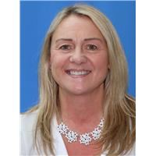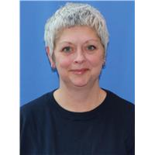  Here in Kirklees, we have two full time School Safeguarding Officers, who have a wealth of experience and a range of specialisms and expertise which enables us to provide a professional and comprehensive range of safeguarding support to schools and academies.  We can advise on, and contribute to the development, delivery and implementation of policies, procedures, and safeguarding strategies within individual settings. | Contact us on:  SchoolSafeguardingOfficer @kirklees.gov.uk  01484 221919 | Kirklees School Safeguarding Officers  Safeguarding training and support  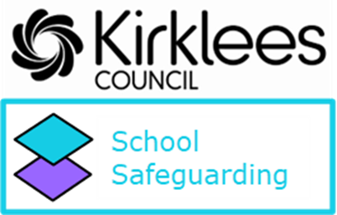
What We Offer  - Safeguarding training and support  - Provision of safeguarding updates (national and local authority) to head teachers and Designated Safeguarding Lead professionals  - Attendance at Head Teacher Forums and Designated Safeguarding Lead Forums  - Telephone and face to face consultation as required (between 9 am and 5 pm Mon- Fri) 01484 221919  - Monitored email support at schoolsafeguardingofficer@ kirklees.gov.uk  (For non-urgent advice between 9 am and 5 pm Mon- Fri)  - Administration of the annual Schools Safeguarding Audit.  - Annual traded charge based on 45p per child on role at the last census | Basic Awareness in Child Safeguarding  Discounted cost  Course size up to 50 delegates - £250  Course size up to 100 delegates - £400  Non-traded cost  Course size up to 50 delegates (minimum 20 attendees) - £350  Course size above 50 delegates (maximum 100 attendees) - £550  Bespoke School Safeguarding Review  Approximately 5-6 hours  Completed in school which includes a tailored report.  Discounted cost  £160  Non-traded cost  £210 | DSL Training  Discounted cost  Roles & Responsibilities of the DSL (full day course) - £85 per delegate  DSL Refresher Course – (half day update course) - £50 per delegate  Non-traded cost  Roles and Responsibilities Course (full day course) - £110 per delegate  DSL Refresher Course (half day update course) - £65 per delegate

