Elective Home Education (EHE)

What is Elective Home Education?

Elective home education is a term used to describe a choice by parents to provide
education for their children at home - or at home and in some other way which they
choose - instead of sending them to school full-time. This is different to education
provided by a local authority otherwise than at a school - for example, tuition for children
who are too ill to attend school.

Parents Responsibilities

The responsibility for a child’s education rests with the parents. It is a parent’s legal duty to ensure children receive suitable education either by regular attendance at school or otherwise (the term “or otherwise” can mean at home)

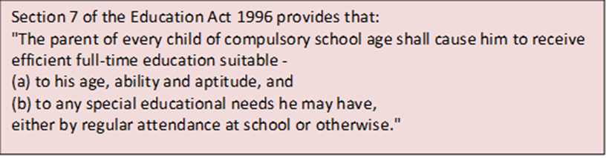

When electing to home educate parents assume full financial responsibility, including the costs of any public exams. If parents use tutors or out of school settings, they are responsible for ensuring they are qualified including making DBS checks.

What is a suitable education?

The law does not define ‘suitable’. Parents do not have to follow the national curriculum or stick to a timetable. Some parents adopt an ‘educational philosophy’ e.g., Autonomous,
unstructured/structured. There is an expectation that literacy and numeracy are learned, and that the child when grown up should be able to function as an independent citizen. EHE children do not have to sit formal exams, some do as private candidates.

Reasons for Elective Home Education

There are many reasons why parents choose to educate children at home, including those set out below:

- Ideological or philosophical views which favour home education, or wishing to
provide education which has a different basis to that normally found in schools
- Religious or cultural beliefs, and a wish to ensure that the child’s education is
aligned with these
- Dissatisfaction with the school system, or the school(s) at which a place is
Available
- Bullying of the child at school
- Health reasons, particularly the mental health of the child
- As a short-term intervention for a particular reason
- A child’s unwillingness or inability to go to school, including school phobia
- Special educational needs, or a perceived lack of suitable provision in the school system for those needs
- Disputes with a school over the education, special needs, or behaviour of the
child, in some cases resulting in ‘off-rolling’ or exclusion
- As a stopgap whilst awaiting a place at a school other than the one allocated

Local Authority Responsibilities

The local authority has a duty to identify all children not receiving a suitable education and should work with partner agencies to increase knowledge of children not attending school.

If a local authority is aware that a child of compulsory school age is not attending a state or registered independent school full-time, and it is unclear how that child’s education is being provided, a local authority should consider the possibility that the child is being educated at home by its parents. In such a case, the local authority’s task is to find out how he or she is being educated and whether that education is suitable. If it appears EHE is not suitable the local authority must act, this could result in a School Attendance Order being considered.

What is Flexi Schooling?

Flexi-schooling describes an arrangement between the parent and school where children are registered at the school in the usual way but attends school part-time. For the rest of the time, the child is home-educated.

Unlike full-time home education, any agreement between parents and a school for the child to be flexi-schooled is at the Head Teacher’s discretion. Flexi-schooling can be a long-term arrangement or a short-term measure for a particular reason. The child will be required to follow the National Curriculum whilst at school, but not whilst they are being educated at home.

There may be many reasons why parents may want to arrange flexi-schooling for their children, for example:

- Illness
- A desire to home educate while making use of the school for some subjects
- School phobia/refusal
- Allowing time for a special ability, such as music, sport etc.
- A phased return to school after an absence for some reason.

Flexi-schooling is also different from a temporary part-time timetable. Part-time timetables are put in place on an exceptional basis for a time-limited period for circumstances such as medical intervention or to meet a pupil’s individual needs.

Advice for Professionals

- If you are working with or know of a child who is home educated, please check the local authority is aware they are EHE - the local authority has a duty to identify all children not on a school roll. If a child is home educated, the local authority needs to ensure they are receiving a suitable education.
- If you are concerned about the suitability of the EHE provision - please make the local authority aware of your concerns.
- If you have any safeguarding concerns about an EHE child - please follow Kirklees Safeguarding protocols.

The EHE team can be contacted at 01484 221919 or by email at EHETeam@kirklees.gov.uk

The team are happy to deliver briefings on EHE to partner agencies - if you think this would be helpful, please contact us.

Further reading and guidance:

Elective Home Education | Kirklees Council

Elective home education - GOV.UK (www.gov.uk)

