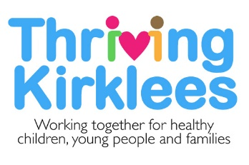

Thriving Kirklees

Service Offer for Families and Young People

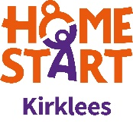
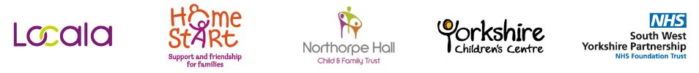
Locala 0-19 Service

Getting advice and Signposting
- Healthy Child Programme Core contacts:
  - Antenatal - between approximately 32 and 36 weeks gestation – Face-to-face (currently not all families receive this, dependent on need)
  - Birth visit - before 28 days – Face-to-face
  - 6-8 week assessment – Telephone, virtual or face to face contact dependant on need
  - Immunisations at 8, 12 and 16 weeks - clinic or GP
  - Pre-One year assessment - Appointment in a clinic setting
  - Immunisations at 12 and 13 months
  - Two-year assessment - Appointment in a clinic setting
  - Children in an Early Years Setting (EYS) will be assessed by EYS in some areas
  - Immunisations at 3 years and 4 months
  - Reception year screening National Child Measurement Programme (NCMP) – growth (height and weight) and vision screening. Online parental self-assessment, can self-refer where indicated.
  - Year 6 NCMP- growth screening (height and weight). Digital transition presentation.
- Aiding in implementing school guidance for children with medical conditions
- Nurturing Parents - Preparation for Parenthood course - 6-week programme available to all “parents to be” virtual or face to face. Online parenting course also available.
- Community Clinics - bookable appointments and drop in sessions
- Chat health - Text service for advice and support. Two lines, one for young people 07520 618866 and one for parents and carers 07520 618867.
- Duty 0-19 team – for advice and support 8am-6pm 0300 304 5555.

Getting Help
- First line interventions, care pathways:
  - Healthy lifestyle and healthy eating advice
  - Behavioural support – including sleeping, potty training and temper tantrums
  - Emotional support with any aspect of parenting including postnatal depression, violence within the family and bereavement.
  - Helping parents and young people to improve their emotional health and wellbeing, self-esteem, anxieties, low mood.
  - Sexual health advice and support
  - Drug and alcohol misuse
- Telephone advice, self-help strategies, signposting to other services.

Getting Risk Support
- Safeguarding- attending case conferences, core groups, health interventions with the Family
- Looked after children health assessments. Every 6 months to under 5 year olds and yearly for 5-19 year olds.
- Nurse advisors for Looked after children, Alternative Provisions (was PRU), Youth Justice Service and Family Nurse Partnership.
(Note: The italics above are services not part of Thriving Kirklees, but provided by Locala for children in the cohort)

Emotional Health & Wellbeing Pathway

Emotional wellbeing and mental health support is delivered through ChEWS (Children’s Emotional Wellbeing Service) at Northorpe Hall Child and Family Trust and CAMHS (Child and Adolescent Mental Health Service) at South West Yorkshire Partnership Trust. There is also the MHST (Mental Health Support Team) which is a parentship with SWYT, Northorpe Hall and Education Psychology working with some schools in Kirklees.

Getting advice and Signposting
TK Single Point of Access Emotional Health and Wellbeing Pathway
When contact is made via the single point of contact for the emotional health and wellbeing pathway an initial call will be booked with the family for an initial discussion regarding any concerns. As part of the discussion advice and signposting information will be provided. If it is felt that emotions are impacting on daily functioning, there is any risk or needs require to be explored further to fully understand the current situation a full assessment will take place collecting the views of the young person and other adults in their life supporting them. Once the information is gathered this will be reviewed and a support decision made. This may be further advice or strategies, a service within the TK partnership or support to access a service outside the TK Partnership to best meet the current needs.
Workshops and Information Sessions

A number of free workshops are available for parents, children and young people in Kirklees to find out more about common concerns impacting on emotional wellbeing, helpful responses and strategies to support these.

To see what workshops are currently available and to book onto sessions please click the following link -
https://chewsnews.northorpehall.co.uk/workshops.php

Education Link Work

Support regarding the whole school approach to emotional health and wellbeing, staff training, parent workshops and emotional wellbeing networks are available for education providers to access as requested.

To access any of this support you can email the following link:
educationlink@northorpehall.co.uk

Family Placement Consultation and Emotional Wellbeing Clinics
Consultation and Emotional Wellbeing Clinics are available for children and young people in Kirklees who are Looked After or have a social worker. This can be accessed via the allocated social worker.

Getting Help
The following interventions are available as part of ChEWS, providing short term interventions.

- Focused Group Work Interventions:
- Anxiety & Low Mood: MoodMaster CBT based group intervention programme.
- Timid To Tiger: Parent/carer lead CBT based group intervention programme.
- Direct 1:1 Interventions: Emotional wellbeing support, mental health intervention and counselling support where emotions are impacting on daily functioning.
- Cygnet: Parent/carer support programme for those supporting a child with a diagnosis of ASC
- SilverCloud: Silver Cloud is an online self-help cognitive behaviour therapy programme to help manage anxiety and low mood. There are programmes for young people 15+ and there are also some parent programmes.
In addition, there are extra modules available around sleep, relaxation, self-image, resilience, and friendships. There is a phone app to make this more accessible.
Programmes include –

- Supporting an anxious child
- Supporting an anxious teen
- Space from anxiety for teens
- Space from low mood for teens
- Space from low mood and anxiety for teens
- Space for Resilience
- Space for Positive Body Image

Getting More Help
Thriving Kirklees CAMHS (SWYPFT) provides interventions to children and young people, including those with a Learning Disability (LD), who present with persistent and significant difficulties with the following:

- Depression (where severe or they have not responded to earlier intervention)
- Self-harm and suicide attempt
- Severe anxiety (including obsessive compulsive disorder)
- Eating disorders with significant risk or impairment (such as anorexia nervosa or bulimia)
- Psychosis (in those aged under 14)
- Prolonged adjustment difficulties eg abnormal grief reactions
- Persistent post-traumatic disorder (PTSD)
- Challenging Behaviour (LD/ASC Intensive Support Team only)

Our aim is to improve the mental health of individuals accessing our service, and we work closely with other Trust and community services to ensure the needs of the individual are best met.

We work alongside other organisations; including Children’s Social Care, Children’s Health and Wellbeing services, Schools, School Nurses, and other community-based organisations.

The support available includes -
- Vulnerable children’s team for health and emotional wellbeing support
- Eating disorders team
- Learning Disability Nursing Team
- Specialist partnership goal focused interventions
- Attention Deficit Hyperactive Disorder (ADHD) treatment interventions
- Psychiatry support
- Crisis/Intensive Home-Based Treatment (IHBT)
- Psychological interventions
- Complex Case Consultation
- 24/7 Crisis response / Intensive Home-Based Treatment team.
- ASC Intensive Support Team

Getting Risk Support
Crisis Team / Intensive Home-Based Treatment Team
Mental health inpatient care/support
ASC Intensive Support Team

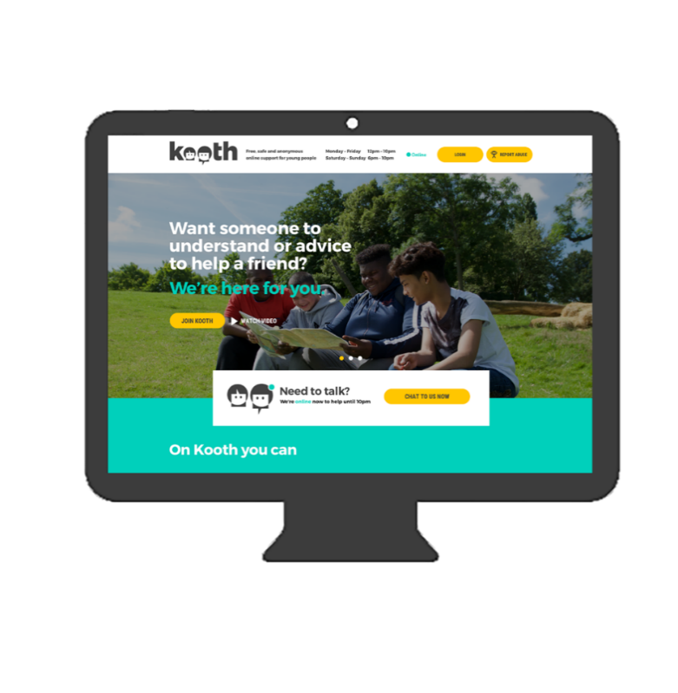
Kooth
Kooth is a free, online counselling and emotional wellbeing platform for young people in Kirklees aged 11 to 25 (you can use Kooth until you turn 26 yrs old).
The Kooth website allows young people to gain anonymous access to advice, support and guidance on any issue that is affecting their wellbeing. From friendship or relationship issues, family disagreements or difficult home lives, to concerns around eating, anxiety, stress, depression, self-harm, suicidal thoughts etc.
Qualified counsellors are available to give young people the support they need, when they need it. Kooth.com’s live chat service is available from Monday to Friday 12 noon - 10pm, Saturdays and Sundays 6pm - 10pm and is accessible through mobile, tablet and desktop, completely free of charge.
Access via the website www.Kooth.com

Neurodevelopmental Assessment

The Neurodevelopmental assessment service offers diagnostic assessments where there are concerns regarding possible Autism Spectrum Condition or Attention Deficit Hyperactivity Disorder.
Please note:
- Referrals will only be accepted from professionals who know the child well and can provide the level of information needed to understand if the neurodevelopmental assessment pathway is appropriate for them. Ideally this would be a professional who sees the child on a daily or weekly basis.
- Professionals who cannot provide the level of information needed are encouraged to discuss with parents and identify another professional who knows the child better who could make the referral.
- Parents cannot refer for a diagnostic assessment. If the child is home-schooled and has no other professional support, then the parent can contact the assessment team for further advice.

The process is:
- The referrer telephones the Thriving Kirklees neurodevelopmental assessment service on 01484 343184 to book an appointment for a telephone consultation.

- A member of the referrals team will call the referrer at the agreed appointment time to discuss the referral. The appointment will take at least 30 minutes. The neurodevelopmental assessment service will ask a set of questions and will record the information required. The referrer is informed if the referral is accepted or declined for assessment either at that time or within 2 days if there is complexity that requires a team discussion. If accepted the clinician will advise the referrer of the current waiting time for a full assessment. If declined the reasons will be explained with information about what needs to happen next.

- A letter is sent to parents / carers and copied to the referrer confirming the outcome of the referral and accepted referrals are added to the waiting list.

Home-Start Kirklees

Homebased support for families
(for any families in Kirklees with a child under 5 years not yet in full time education)
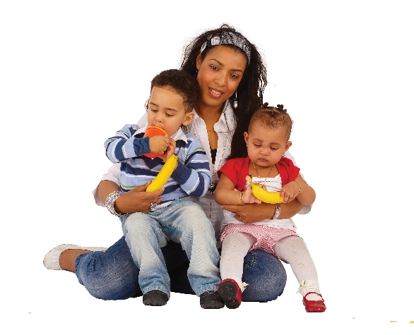
Families referred to Home-Start Kirklees can be offered a trained volunteer to support weekly by visiting the family in their home for up to 2-3 hours per week. Volunteers offer practical help and emotional support to parents who may be struggling with everyday life and parenting challenges e.g., housing, budgeting, behaviour and routines etc... Parents who maybe need someone to talk to, help with the children or help to access other services and community-based provision.
Volunteers are carefully matched to families and offer support for as long as it is needed. Home-Start Co-ordinators supervise the volunteers and keep in touch with families to ensure that they receive the right support and that it’s having a positive impact. The family’s needs are regularly assessed to ensure support is still relevant and is helping. Home-Start support is confidential and is tailored to meet the needs of individual families. Support can be long term if needed.
https://www.youtube.com/watch?v=o0q8F82Ml24
Weekly group peer support for young parents
The Young Parents’ Service helps young parents (aged 14-24 years) to take greater control over their lives and increase their prospects through providing peer to peer support, education and training. We build and promote resilience through early intervention to reduce poor mental health and health inequalities and keep young parent families safe. Some young parents face complex family life challenges and need long term bespoke support to achieve positive outcomes to ensure they can live independent, healthy lives and are fully equipped with the life skills needed to support their children.
Support is flexible for young parents via weekly group support sessions and 1 to 1 home-based support. Young parents are supported by Group Co-ordinators and our trained Peer Educator volunteers who are often former service users. The outcomes are that young parents’ mental health improves, they feel less isolated and lonely, they learn how to become confident, positive parents and are able to move into employment or education and live independently of other services. Support can be long term if needed.
https://youtu.be/SKQGHidZdTc
Peer Educator support (group support and 1 to 1 support for young parents)
Peer Educators have been young parents themselves and have first-hand experience of some of the difficulties and challenges young parents face. They undergo specific Home-Start training to upskill and prepare for the role and are there to help other young parents individually or in group support sessions that are referred into the young parents service.

Telephone Befriending
For families who need more emotional support rather than practical help, we offer a telephone befriending service where once a week a matched volunteer will chat to a parent for as long as needed and offer an essential listening ear. Support can change to home-based home visiting support from a volunteer, should it be required.
School Readiness
Home-Start offers families support with preparing children for future learning. Raising awareness of school readiness and what it means is essential for parents to fully support their children with home-based and community learning opportunities. Parents/carers are gifted a school readiness resource kit which provides information, ideas/suggestions for play and interaction. Parents are guided by advice and role modelling on how to play, engage and stimulate their children and what best helps them become socialised, confident, and ready for nursery or school setting e.g., sharing books, joining the library, 50 things etc…. The key focus of this support is confidence building, early essential socialisation skills, communication and language.
Weekly Group Peer Support Sessions
For families who need more peer support to tackle loneliness and isolation, Home-Start (from February 2023) will offer weekly group support sessions for parents referred (please note: this is not a universal offer). Support is flexible for parents via weekly group support sessions and 1 to 1 home-based support is also available if needed. Parents are supported by group staff and trained volunteers. The outcomes will be: improved parental mental health, less isolation and loneliness and confident parenting. Parents are able to transition into local community-based provision with help (and handholding if need be). Children will have opportunities to play and socialise. Group support is a limited intervention.
Child Poverty Fund (Affordable Warmth)
Home-Start Kirklees provides essential items to families to help them keep safe and warm in the winter season. We fundraise throughout the year to provide families with blankets, bedding, children’s outdoor wear etc…. The fund can be accessed all year round for those families who are struggling to provide the most basic essential items for their children (Please note: this fund is only available for Home-Start families who are receiving support).
How to receive Home-Start support
To receive Home-Start support parents can either call us to self-refer or can be referred by any professional who is already supporting the family.

Yorkshire Children’s Centre

Safety in the Home Service

Eligible* families living in Kirklees with children under 2 years old are provided with free home safety equipment, which is fitted in their home. The safety equipment supplied includes: safety gates, fire guard, bath mat, cupboard locks, corner cushions, blind cord winders and window restrictors.
Families also receive:
- a free home fire safety check
- new smoke detectors fitted where required
- child accident prevention and home fire safety information and advice
- Risk reduction assessment

*To be eligible families must live in Kirklees, have a child under 2 years old and be in receipt of benefits, or be on a child in need/protection plan. For the full list of eligibility criteria please visit http://yorkshirechildrenscentre.org.uk/our-services/support-for-families/safety-home/
Safety Rangers
Year 5 primary school children from schools in areas of high deprivation in Kirklees attend Safety Rangers at local Fire Stations. The aim is to reduce and prevent childhood accidents and improve child health and wellbeing through a variety of interactive, fun teaching methods and scenarios.
Topics covered include home and seasonal fire safety, road safety, anti-social behaviour, emotional health and wellbeing and physical health and nutrition. The scenarios are delivered by our partners - West Yorkshire Fire and Rescue Service, Kirklees Council Road Safety Team, West Yorkshire Police, South & West Yorkshire Partnership Foundation Trust, Northorpe Hall and Huddersfield Town Foundation. Safety Rangers runs four times a year for two weeks, and the children attend for a full day.
Healthy Start
‘Healthy Start’ is a statutory Government scheme and is designed to provide financial help to improve the nutrition of families receiving certain benefits. Qualifying pregnant women and families with young children are provided with a Healthy Start debit card which is topped up every 4 weeks, this can be used to buy cow’s milk, fresh or frozen fruit and vegetables and infant formula. Qualifying families will also be entitled to free maternal supplements and/or child vitamin drops. Families that are eligible can collect their vitamins from various distribution centres across Kirklees – the location of these can be found by visiting: www.nhs.uk/service-search/other-services/healthy-start-vitamins/locationsearch/348

Yorkshire Children’s Centre’s (YCC) role is to administer and promote the National Healthy Start Scheme. YCC want to work better together with professionals that families are already being supported by to help educate, raise awareness and to increase the accessibility of vitamins- overall encouraging uptake by those families most in need.

How do families qualify for Healthy Start?
- If you’re at least 10 weeks pregnant or have a child under four years old and you or your family receive:
- Income Support, or
- Income-based Jobseeker’s Allowance, or
- Income-related Employment and Support Allowance, or
- Child Tax Credit (with a family income of £16,190 or less per year), or
- Universal Credit (with a family take home pay of £408 or less per month)
- You also qualify if you are under 18 and pregnant, even if you don’t get any of the above benefits.

For further information on the qualifying criteria, families are advised to visit the following web address: www.healthystart.nhs.uk
How to apply?

Families must complete an online application form which is accessible on the Healthy Start website: www.healthystart.nhs.uk/how-to-apply/ If the application is deemed successful, families will receive their Healthy Start debit card in the post within 3-5 working days.

The paper application pathway was ceased in March 2022, therefore there is no alternative method of applying. However, if families are unable to access the online form, they should be encouraged to contact Yorkshire Children’s Centre who can provide additional support via email: thrivingkirklees@yccuk.org.uk or Tel: 01484 415465

Child Accident Prevention

YCC leads on child accident prevention within the Thriving Kirklees partnership. We help to upskill 0-19 professionals and provide information to schools and families on how to prevent childhood accidents.

This free training course is designed to raise the awareness of parents, carers, and practitioners of the causes of childhood accidents, by teaching adults how to reduce risks and keep children safe.
About Accident Prevention eLearning
Unintentional childhood injury results in over 2 million visits to A&E in the UK – Over half of these injuries occur in the home. On average 62 children under the age of five died as a result of an accident and over 76,000 under the age of 14 are admitted for treatment, of which over 40% are under 5 years of age.
This e-learning course enables parents, carers, and practitioners to:
- Identify risks in the home and elsewhere that are the common causes of childhood accidents
- Describe steps you are able to take in order to reduce the risk and prevent childhood accidents
- To be confident in making changes or supporting families to make changes, to keep children safer.
- The training takes approximately 30 – 40 minutes to complete. On completion you will receive a certificate.

If you are a parent/carer of a young child/ren or a professional working with/supporting young children, we strongly advise you to complete this training to develop your knowledge on child accident prevention. This will enable you to go on to make a difference in reducing childhood accidents in Kirklees.
To access the training please go to the Kirklees Safeguarding Children’s Partnership website and register (if you are not already a registered user) www.kirkleessafeguardingchildren.co.uk then follow the steps below:
- Register and book training today
- eLearning
- Child accident prevention eLearning
- More information and booking
- Log in or Register
- Open training

Contacts

Support from a Thriving Kirklees Practitioner:
To make a referral to a Thriving Kirklees service please use the support request form available via www.thrivingkirklees.org.uk/referral-form

Please note:

To access Home-Start Kirklees services ONLY, please ring 01484 421925.

To access Safety in the Home and Safety Rangers, please call Yorkshire Children's Centre on 01484 415465.

For more information or to raise a query about a service, please contact the service partner direct:
Locala: 0303 3309588
Home-Start: 01484 421925 www.homestart-kirklees.org.uk
Yorkshire Children’s Centre: 01484 519988 www.yorkshirechildrenscentre.org.uk
Northorpe Hall: 01924 492183
SWYFT: Contact via Northorpe Hall

For families and young people:

Please signpost them to:

- Thriving Kirklees website www.thrivingkirklees.org.uk
- Or telephone SPoC (Single Point of Contact) 0300 304 5555 (available 24 hours a day, 7 days a week)

Last updated: December 2022

