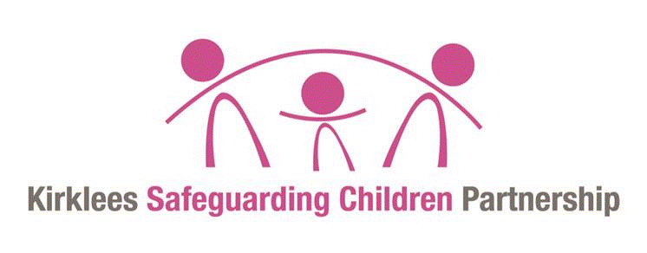
This document is intended to explain Child Protection conferences to parents and families.

What is a Child Protection Conference?
A Child Protection Conference is a meeting between families and a number of professionals that is held when there is a concern about the safety of a child within a family.

The purpose of the conference is to:
- Share information about a child’s health, safety and wellbeing.
- Assess whether a child is suffering or likely to suffer significant harm.
- Identify the strengths within the family
- Identify any support needed by the family and the professionals / agencies and who might be able to provide this.
- Identify changes needed (if any) to ensure the safety of the child.
- Decide if the child needs to have a child protection plan.

A child protection conference does not make decisions about legal or court action, or about where children should live.

As a parent, you are invited to attend the conference and are encouraged to take an active part. You may also bring someone with you to support you. This can be another member of your family, a friend, or some other person of your choice.

Who else will be at the conference?
An independent person will chair the conference. There will also be someone to take notes at the meeting.

A number of professionals will also be invited to the meeting and prepare a report which they should share with you in advance. Examples are:
- Social Worker.
- Police representative.
- Health Visitor, midwife or school nurse.
- Teachers
- Your child (if over 10 years of age and if it is appropriate for them to attend)
- Child’s Advocate
- Any other professional involved with your family.

All professionals who are involved with your family will be invited, but there may also be some individuals and some agencies represented whom you have not met before. These individuals are invited because of their expertise or because they might be able to provide help. You will be introduced to everyone at the start of the conference.

What happens at the initial conference?

The Chair of the conference will speak with you prior to the meeting being held to explain how the conference will run and to talk about the best way for you to contribute to the discussion. If any of the attendees have confidential contact information which they think needs to be kept from another attendee at the conference, this needs to be raised with the chair before the conference begins.

The aim of the conference is to work with the family to discuss what the concerns are and draw a plan together to keep your child/ren safe and give your family the support you may need.
The conference will talk about the strengths and positives that are in your family and we will build on those.
Key information is written on sheets at the front of the room. The strengthening families framework is used to clearly map the information under the headings (harm; strengths; safety/protective factors; complicating factors; grey areas) for all to view, and the family get the opportunity to respond in a structured way.
A decision will be made about whether the risks to your child are significant enough that a Child Protection Plan is needed.

A child protection plan is a list of actions with details of who is to carry out these actions and over what timescale.

You should come out of the conference clear about what (if anything) needs to change. More detailed plans are usually made at a later meeting between you and the relevant professionals. This meeting is called a Core Group and should happen within 10 working days of the initial conference.

How can you prepare?

During the conference you will be given the chance to comment about what others are saying and to give your own information and views. You will also be asked what you think should happen in the future, including any help that you feel is necessary.

Many families who have attended conferences in the past tell us that they were very nervous and didn’t say as much as they would like to. To help overcome this, it is useful to do some preparation in advance.

Many of the professionals who come to the conference will have already prepared a report – setting out the facts, as they are known, their views and ideas. Some families do the same. If you would like to do this, talk to your child’s Social Worker about it as they may be able to help you.

If you don’t want to produce written information, you could still do some preparation before the meeting – and perhaps bring along notes for yourself as a prompt. Examples might include:

- Strengths
What do you think are the strengths in your family?
What are the things that you think you do well?
What positive things would you like professionals to know about you and your family?

- Risks/concerns
What (if anything) do you think needs to change for your child to be safe?

- Services/support needed
Does your family need any additional services or support?
How would this support help?

- Next steps
What do you think you or others could do to improve the current situation?

What happens after the conference?
Within 15 working days after the conference, you will be sent a copy of the notes from the meeting.

If a child protection plan is made, you will be asked to attend regular meetings called Core Group meetings, which are held at 6-week intervals or more often if necessary. At these meetings you will look at the plan and discuss what progress has been made.

A Review Conference will be held at regular intervals for as long your child is the subject of a child protection plan. The review can be convened at any time but no later than 3 months after the initial conference and 6 monthly thereafter. After each review conference another decision will be made regarding whether your child/ren need to remain on a Child Protection Plan or not.
It may be that your child does not receive a child protection plan, but that the discussion has identified support that may benefit your child and family. If this is the case, then the plan devised during the meeting will be a CIN (Child in Need) plan. The relevant professionals will meet with you from time to time to discuss how this plan is progressing.

What can you expect from us?
We want to work in partnership with you and your family. As a parent/carer, you should expect to:
- Be listened to.
- Be treated with respect.
- Be kept informed and involved in decisions.
- Get all the help and support that has been offered to you within the agreed timescales.
- Receive a reliable service, with professionals doing what they say they will.
- Receive copies of all reports three working days in advance.
- Confidentiality is very important, and you will find that the Chair will remind everyone present at the conference about this.

If you have questions, you can ring the independent chairperson of your meeting at any time. Their name will be on your conference invite and the number is 01484221000.

