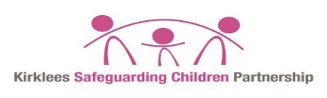
Escalation Policy
Index
Introduction | 1
Escalation is….an effective mechanism for resolving professional disagreement.’ Escalation is not…. a negative action or criticism | 2
Principles of Resolving Professional Disagreement | 3
Process of Resolving Professional Disagreement  - Step 1  - Step 2  - Step 3  - Step 4  - Step 5  - Step 6 | 4
Appendices  - Appendix 1 - Escalation at point of referral.  - Appendix 2 - Escalation for ongoing cases  - Appendix 3 - Escalation for Child Protection Conferences  - Appendix 4 - Child Death Overview Escalation Process | 6  7  8  9  10

Introduction
When working in the arena of safeguarding children and young people, it is inevitable that at times there will be professional disagreement between practitioners. Whilst this is accepted, it is vital that such disagreements are not allowed to adversely affect the outcomes for children and young people. Professional disagreement is only dysfunctional if it is not resolved in a constructive and timely way. This protocol therefore provides a process for resolving professional disagreement between agencies.
When there is disagreement between agencies, this should be recognised as an opportunity for healthy debate. The purpose of this protocol is to facilitate the resolution of operational disagreements where an agency considers that, without such action, there could be a negative impact on a child’s well-being
Disagreement can arise in a number of areas of multi-agency working, as well as within single agency working; in the multiagency arena they are most commonly seen in relation to:
- Criteria for referrals
- Outcomes of assessments
- Roles and responsibilities of Practitioners workers
- Service provision.
- Information sharing and communication.
Disagreement can relate both to decisions about individual children and specific processes.
This protocol focuses on disagreement between agencies in relation to individual children and is applicable to all agencies, including the Voluntary, Community and Faith (VCF) sectors.
- What is Escalation

Escalation is a process of formally challenging a decision made by a practitioner, agency, or organisation. Escalation procedures ensure that all practitioners have a quick and straightforward means of resolving professional difference and disagreement.
Escalation is….an effective mechanism for resolving professional disagreement.’ Escalation is not…. a negative action or criticism
Safeguarding is everyone’s responsibility and Practitioners should be confident in talking with each other about decisions that have been made, discussing any concerns regarding those decisions and, where agreement is not able to be reached; escalating those concerns as appropriate to seek resolution.
Professional disagreements should be seen as part of ‘healthy’ professional working relationships and practitioners should be encouraged to give or receive professional challenge in a constructive and supportive way.

Equally important is the culture of how we work; and it is vital that front-line staff are encouraged to remain professionally curious and feel able to raise any issues they have when they feel concerns they may have for children and young people are not being addressed.
Effective working together depends on an open approach and honest relationships between agencies. Problem resolution is an integral part of professional co-operation for joint working to safeguard children.
Most disagreements can be resolved through discussion and negotiation. Practitioners should adopt a restorative approach to seeking resolution that allows everyone’s perspective to be heard.
Resolution
When working with children and families professional disagreement can be positive, challenge allows for reflection and review, and can foster creative ways of working. However, professional disagreement can impact negatively on positive working relationships and consequently on the ability to safeguard and promote the welfare of children. Disagreement always requires resolution.

Challenge
Challenge’ does not mean ‘conflict’; it is simply an opportunity to have a conversation about what could be done in a different way or what needs to change. Practitioners need to be managed, supported and equipped to work with families in ways that are high in support and high in challenge in a multi agency system.”

Escalation - Principles
Effective working together depends on an open approach, clarity of roles and responsibilities and genuine, honest, professional relationships. Escalation is a means of resolving professional difference and is an integral part of joint working to safeguard children. Kirklees Safeguarding Children Partnership encourages challenge to support effective safeguarding. All agencies across the partnership have agreed to adopt the principles of restorative practice to engender genuine partnership working.

The safety and wellbeing of individual children and young people is the paramount consideration in any effective challenge and escalation.
- Effective challenge is a positive action.
- Practitioners should take responsibility for their own work and actions.
- Any disagreements should be resolved as simply and quickly as possible.
- Practitioners and managers should respect the views of others, whatever their level of experience, the role they fulfil, or the agency they represent.
- Practitioners and managers should always be prepared to review decisions made with an open mind
Working together effectively depends on a genuine commitment to partnership working and resolving disagreements at the earliest opportunity.

Professional disagreement can relate to, but is not exhaustive to:

- Dispute at the point of a referral due to differing opinions.
- Concern about the action / inaction of another practitioner/agency
- Disagreement about decision making and a course of action.
- Dissent at / arising from a Child Protection Case Conference.
- Disagreement over information sharing.
- Disagreement over an assessment and joint decision making.
- Disagreement over the provision of services.
- Concern there is drift or unreasonable delay in a case.

The safety of individual children is the paramount consideration in any professional activity and resolution of professional disagreement should be sought within the shortest timescale possible.

2. Principles of Resolving Professional Disagreement
- The safety and wellbeing of individual children / young people must remain the paramount consideration in any professional disagreement. Professional disagreement which obscures focus on the child / young person must be avoided.

- Professional disagreement should not be viewed negatively; it can improve outcomes for children and young people and provide important learning for the practitioners / agencies involved.

- Disagreement at practitioner level should be resolved as simply and quickly as possible. If this is unsuccessful, the challenging agency should formally communicate that this protocol will be implemented, and the disagreement should be escalated to the challenging agency’s Safeguarding Lead and/ or the relevant Line Manager, to agree and record.

- All practitioners and Senior staff should respect the views of others, whatever their level of experience.

- Working together effectively depends on an open approach, and honest relationships between agencies. It also depends on a genuine commitment to partnership working and seeking to resolve disagreement to the satisfaction of practitioners and agencies.

- Attempts to seek resolution may leave a practitioner / agency believing that a child(ren) is at risk of harm. The practitioner / agency who has concerns is responsible for communicating these through their line management and/or to the Safeguard Lead for their organisation.

- Professional disagreement can be resolved at any stage and it is the responsibility of all the agencies involved to achieve the best outcome for the child(ren).

- To avoid delay, it is expected that professional disagreement will be resolved quickly at the lowest level; if escalated each step in this process should not exceed 5 working days.
3. Process of Resolving Professional Disagreement
The following stages are likely to be involved:
- recognition that there is disagreement over a significant issue in relation to the safety and wellbeing of a child / young person.
- identification of the problem.
- discussion of the possible cause of the disagreement; and
- agreement on what is required to in order to achieve resolution

Step 1 – Emerging disagreement: Practitioner discussion
The process of resolving professional disagreement should initially involve practitioner liaison to clarify decision making, for example, via a discussion between Practitioners which promotes reflection and review, using an appropriate practice tool where available, such as the local Framework for Decision making in Kirklees

Step 2 – Written confirmation of emerging disagreement
The following should be considered as part of the process of resolving professional disagreement:
- Initial attempts to resolve the problem should normally be made between practitioners / agencies, at the time the disagreement is identified.
- Both agencies should give clear reason(s) for their concerns and approach, which should be put in writing and, where required, clearly recorded as a formal challenge, as per guidance from their Line Manager and/or Safeguarding Lead.
- It should be recognised that differences in status and / or experience may affect the confidence of some workers in resolving differences, and some may need support from their Managers and/or their Safeguarding Lead.
Step 3 – Escalation to Line Manager
If unresolved, the disagreement should be referred to the practitioner’s Line Manager or Safeguarding Lead to enable a discussion and resolution.
Step 4 – Line Manager Discussion
If the problem remains unresolved, the Line Manager or agency Safeguarding Lead will liaise with their counterpart or refer upwards in accordance with their line management structure, to seek resolution of the disagreement.
Step 5 – Escalation to Head of Service (or equivalent Senior Manager)
If the disagreement is not resolved and professional differences remain, the matter must be referred to the relevant Head of Service (or most appropriate management committee member, commissioner, or funding body) for each agency involved.
Step 6 – Escalation to KSCP Business Unit Manager
In the unlikely event that the disagreement remains unresolved by following the steps described above and/or the discussions raise significant policy issues, the matter should be referred urgently to the Kirklees Safeguarding Children Partnership (KSCP) Business Unit Manager. The Kirklees Safeguarding Children Partnership will determine a course of action including reporting the disagreement to the KSCP Independent Person.
At all stages, a clear record of the progress of any disagreement should be kept by all agencies involved. This must include written confirmation between the agencies regarding agreements reached, and how any outstanding issues will be resolved. Where applicable, records of any learning should be shared with the KSCP Business unit, to aid wider partnership learning and service / practice improvement.
It is imperative that if the escalation process is followed and it should fit the child’s timescale and timely action is paramount if concerns about a child’s welfare /risk of harm have been raised.
Step 7 – Restorative debrief
Following Resolution, to avoid similar professional disagreement occurring again, local protocols and procedures may require amendments. Consideration should also be given to arranging restorative debriefing sessions for those involved, to promote continuing positive working relationships
In some Voluntary, Community or Faith sector organisations, the role of a Senior Manager within this process, may be undertaken by a member of the management committee.
Below are supporting Appendices flow chart documents
Appendix 1 Escalation at point of referral.
Appendix 2 Escalation for ongoing cases
Appendix 3 Escalation for Child Protection Conferences.
Appendix 4 Child Death Overview Escalation Process
Appendix 5 Professional difference Escalation Record

Appendix 1
Escalation framework at point of referral: Professional disagreement/escalation process for ANY child residing in Kirklees
Framework for Decision Making

Immediate Significant Risk
No Immediate risk
Discuss concerns with agency to try and informally resolve issue (Stage 1)
Children’s Social care
Duty & Advice

Professional Number 01484 414960
OR
999
Resolved No Further Action

Discuss concern with line manager agreeing a timescale for follow up
Unresolved

Put into writing within 5 days as a challenge to agency with whom you have a disagreement of decision with (Stage 2). Record and copy in your safeguarding lead/manager (Stage 3)

Decision making/feedback from Duty &Advice to the referring agency with actions and decisions

Safeguarding lead/manager to discuss with counterpart in the other agency (Stage 4)

Refer to Head of Service or equivalent Senior Manager within the service within 5 working days (Stage 5)
Resolved No Further Action

Refer to KSCP Business unit manager for Partnership action including reporting to Independent Person to seek resolution (Stage 6)

Following resolution consider: Stage 7 (Restorative debrief)

Appendix 2
Escalation framework for current Children’s Services cases:
Professional disagreement/escalation process for cases involving ANY child residing in Kirklees
Child Protection, Child in Need, Child Looked After/Early support

No Immediate risk
Immediate Significant Risk
Discuss concerns with agency to try and informally resolve issue (Stage 1)
Resolved No Further Action
Discuss concern with line manager agreeing a timescale for follow up
Duty & Advice Professional Number 01484 414960 or 999
Refer to Appendix 1 for escalation if decision is a matter of concern

Unresolved

Put into writing within 5 days as a challenge to agency with whom you have a disagreement of decision (Stage 2). Record and copy in your safeguarding lead/manager (Stage3)

Safeguarding lead/manager to discuss with counterpart in other agency (Stage 4)

Refer to Head of Service or equivalent Senior Manager within the service within 5 working days (Stage 5)

Refer to KSCP Business unit manager for Partnership action including reporting to Independent Person to seek resolution (Stage 6)

Following resolution consider: Stage 7 (Restorative debrief)

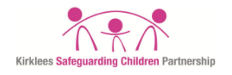
Appendix 3. Child Protection Case Conference escalation
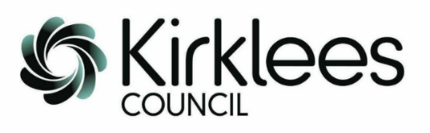

Child Protection Case Conference Escalation information.
Following agreement with the Kirklees Safeguarding Partnership, your name has been provided as a Safeguarding Lead for your agency /organisation.
Safeguarding is a joint responsibility and multi-agency input in the Child Protection Conference process is essential to inform decision making. Agency non-attendance at Child Protection Conferences, failure to provide timely reports for Conferences as required, or any presenting issues that require further exploration will therefore be escalated for consideration/action. Please refer to the procedure regarding agency contribution to the Child Protection Conference process Kirklees-Multi-agency-INITIAL-Child-Protection-Conference-Template 2020 (kirkleessafeguardingchildren.co.uk) .
Date of meeting | Family name, or identifying factors. | CP Chair | Agency | Name of agency Rep | Reason for escalation
An issue has been identified regarding your agency/organisation contribution to the Child Protection process, information of which is provided below.
Please contact the CPRU at CPRU-IRDates@kirklees.gov.uk if you require any further information.
Child Protection Conference partnership training is available to agencies /organisation to provide information and support and assist with clarifying roles and responsibilities. If this would be of interest to your agency, the following link provides course details. https://www.kirkleessafeguardingchildren.co.uk/safeguarding-2/safeguarding-processes-and-systems/multi-agency-training/

Appendix 4: Child Death Overview Escalation Process 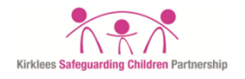 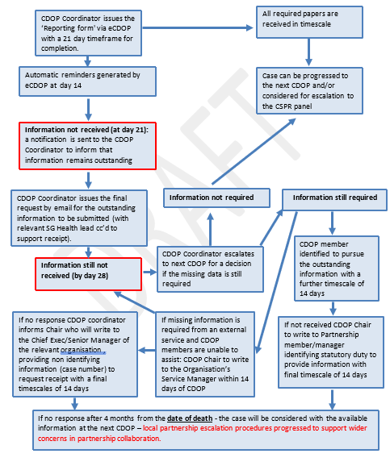
Appendix 5: Professional Difference Escalation Record

