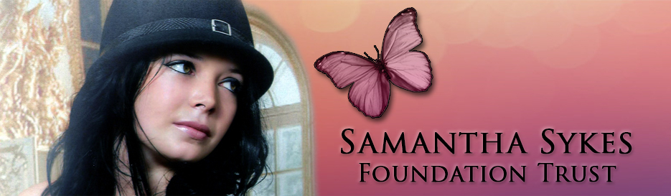

**The Samantha Sykes Foundation Trust (SSFT) are a charity based in Kirklees whose work is to support children and young people who are victims of sexual exploitation. SSFT have received funding from the Office of the Police and Crime Commissioner to offer therapeutic support to women and girls in the Calderdale and Kirklees areas to address and overcome their experiences of sexual violence and/or exploitation.**

**What can we offer?**

* We are able to offer 14 weeks of one-one therapy with our registered Art Psychotherapist or Trauma Counsellor. Both of whom have a wealth of experience, and a passion for supporting women and girls on their healing journeys after experiencing trauma or abuse.

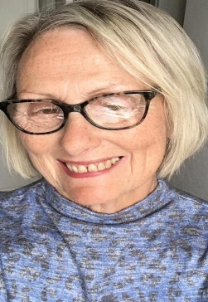 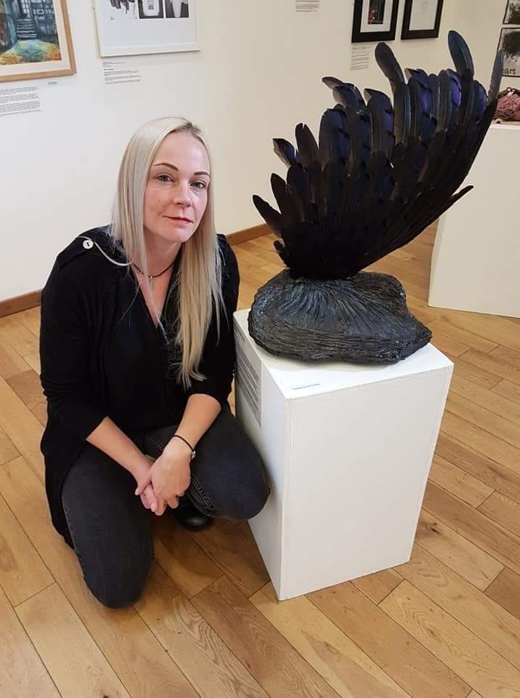

Sue Leanne

Trauma Counsellor Art Psychotherapist

* A warm, person-centred, non–judgemental approach where your individuality and lived experiences will be valued.
* A safe and confidential space to discuss your thoughts and feelings at your own pace.
* Focussed work around how our bodies experience trauma, and how we can work with our bodies to promote healing.

**How will it work?**

* Our therapists will work side-by-side with you to agree the goals of therapy.
* Women who wish to engage in Creative Therapies will receive a creative pack containing art materials—you do not have to have any previous experiences with art to engage in this therapy.
* Appointments will be held once a week at a time and day agreed between you and the therapist.
* Appointments can be held via telephone or Zoom depending on your preference.
* All women who access this service will be required to give their informed consent before any therapy begins.

***“The connections between and among women are…the potentially most transforming force on the planet”***

**Adrienne Rich**

If you would like to be referred into this service, please complete the form below and send it directly to therapy1@samanthasykesft.net. One of the therapists will contact you to discuss your therapy and complete an assessment.

|  |  |  |  |
| --- | --- | --- | --- |
| Name |  | | |
| Address |  | | |
|  | | | Post code |
| Phone number | |  | |
| Email address | |  | |

**Why do you want counselling at present?** (What has happened to you?)

**Do you want to access talking or art therapy?**

**Have you had counselling previously ?** Yes No

If yes, when and was it useful?

**What do you hope to get from the counselling?** (What learning/changes might you want to make?)

**Is there anything we need to be aware of** e.g access needs, risks, suicide, self harm, use of substances

I give my consent for my information to be shared with SSFT

**Name**

**Signed:** **Date:**

**The Samantha Sykes Foundation Trust is a registered charity: Charity No – 1161175**

**For more information on the work we do please visit our website:**

[**https://www.samanthasykesfoundation.com/**](https://www.samanthasykesfoundation.com/)

**Or follow us on social media:**

**Twitter: @samisykesFT**

**Facebook: @Samanthasykesfoundation**

