**I am worried about the assessment**

We understand that the assessment may be upsetting and that you may feel anxious or worried. We will keep you informed of what is happening and will treat you with courtesy and sensitivity.

If you do not understand any part of the process and need further explanation then please ask the professionals involved who can then provide you with more information.



<https://www.kirklees.gov.uk/beta/children-and-families.aspx>

<https://www.calderdale.gov.uk/v2/council/council-departments/directorates-and-service-areas/children-and-young-people%E2%80%99s-services>

**How can I make a comment about my child’s treatment?**

The Patient Advice and Complaints Team can help in resolving any concerns you may have in regards to health care. Contact them on 0800 013 0018 or email: patientadvice@cht.nhs.uk

**Further information and support**

**Kirklees Children’s Social Care**

Tel: 01484 456848

**Calderdale Children`s Social Care**

Tel: 01422 288001

**National Society for the Prevention of Cruelty to Children (NSPCC)**

0808 800 5000

[www.nspcc.org.uk](http://www.nspcc.org.uk/)

**Family Rights Group**

0808 801 0366 [www.frg.org.uk](http://www.frg.org.uk/)

**Bruising in young babies**

Information for

parents and carers

**A bruise or mark has been noticed on your baby. This leaflet has been provided to explain the Local Safeguarding Children Partnership`s bruising protocol.**

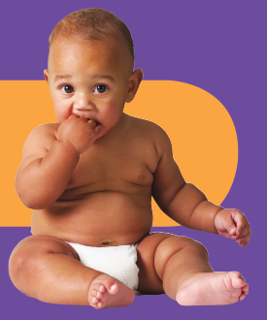

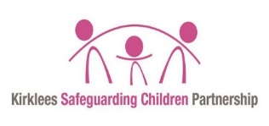****



**Is bruising common in babies?**

**Is bruising usual in babies?**

No. Bruising in babies who are not rolling or crawling is unusual. It is very unusual for a baby to get a bruise during everyday activities such as nappy changes, bathing or feeding.

Bruising can be related to a health condition which has not been previously identified.

However, sometimes bruising in babies is due to a deliberate injury and therefore it is important that each baby is fully assessed to determine the cause.

**What happens now?**

Everyone working with children must follow the bruising protocol (guidance for staff) when they find a bruise, or a mark which appears to be a bruise, in a non-mobile baby (a baby who is unable to move around on their own).

Sometimes, even when children are moving around by themselves, there can be concerns about how a mark or bruise occurred. In these situations a referral should always be made to Children’s Services.

1. A referral is made to Children’s Services.
2. Your baby’s case will be assessed by Children’s Services. Part of this assessment involves gathering information from other agencies who may hold information about your family, or who may be working directly with you.

3. A request will be made for an assessment by a paediatrician at your local hospital or community health clinic. This usually happens as soon as possible the same day.

**What will the paediatrician do?**

The paediatrician will ask you all about your baby. This will include when the bruise was first noticed and whether you know how the bruise may have happened.

The paediatrician will do a full examination which includes undressing your baby. They will ask for your consent as the parent or carer, to perform examinations or other tests. Once the examination has been completed the paediatrician will discuss the outcome of their assessment with you.

There may be a recommendation that further investigations are required such as taking blood from your baby to ensure there are no underlying health conditions.

In some cases, tests such as X-rays or scans may also be requested to enable the paediatrician to fully assess your baby. These tests can take time and may involve staying in hospital overnight, so it would be helpful to take some provisions with you just in case. When X-rays are required, some of them will need repeating in about two weeks.

The paediatrician will also speak to Children’s Services to let them know the outcome of the assessment, and a decision will be made as to whether any further action is needed.