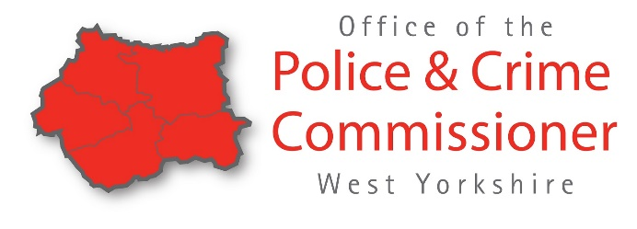
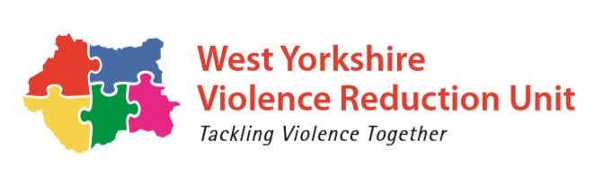
Delivery Initiative Opportunity – West Yorkshire Violence Reduction Unit
5 November 2020 – 31 March 2021
Name of Charity/Social Enterprise
Registered Charity Number
Contact Details: Name
Contact Details: Role
Contact Details: Email Address
Are you currently funded by your local PCC - Yes/No
Description of Charity/Social Enterprise
(no more than 150 words)
What is your support need?
(no more than 250 words)
Total funding requested
Confirm how the funding will be spent/has been spent between 5 November 2020 – 31 March 2021
(please include a breakdown and no more than 150 words)
Where will delivery be?
How many young people are you aiming to engage with/have engaged with?
Any specific communities you will be working with/have worked with?

Please return to: vru@westyorkshire.pcc.pnn.gov.uk by 12noon Monday 15 February 2021

