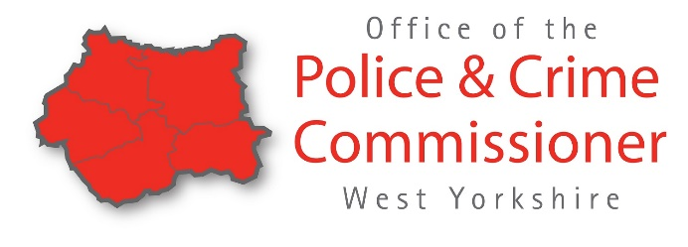
Delivery Initiatives Opportunity for Charities and Social Enterprises
The Police and Crime Commissioner, through the West Yorkshire Violence Reduction Unit, are likely to have available funds for initiatives delivered by charities and social enterprises supporting vulnerable young people at risk of involvement in serious violence, county-lines activity and other forms of exploitation.
We are welcoming bids for a minimum of £30,000 which can be backdated to 5th November 2020. The funding is to support eligible costs incurred from 5th November 2020 until 31st March 2021.
The funding is a one-off contribution of additional support and will require the PCC to issue a Grant Agreement to cover this specific, ring-fenced funding and projects funded must address an identified need, recipients must be able to spend their grant as soon as possible after receipt to support vulnerable young people (0-25 years) and have to ability to cover costs until receipt of the grant funding. Activity is properly costed including funding and resources and must primarily support vulnerable young people aged 0-25 years.
Due to the short time frame of the funding to be utilised we have included some core costs but these must be no be higher than 50% overall and also the purchasing of equipment for activity to take place and provide sustainability.
Examples of costs to support delivery include;
Core costs (maximum of 50% of the total bid)
- Gas and electric
- Rent
- Broadband and phone
- Management and administration staffing costs
- Cleaning and PPE equipment

Activity costs
- Additional staff and volunteer time to deliver projects
- Equipment costs (e.g. IT, sports kit, musical instruments etc.)
- Online delivery
- Course costs
- Staff support such as counselling and mentoring support

The process for funding requests
To ensure a fair assessment is made across all areas, the PCC needs to establish the following as part of our needs assessment process:
- If an organisation is currently funded by the PCC.
- If the organisation is a charity or social enterprise supporting vulnerable young people at risk of involvement in serious violence
- The emergency funding is being provided to secure critical frontline services affected by COVID-19.
- If an organisation is experiencing; immediate financial hardship, significantly increased demand, or an urgent need to adapt services to meet COVID-19 associated measures (e.g. social distancing).
- Activity has or will be delivered between 05 November 2020 and 31 March 2021 (inclusive).
Attached to the email as part of the request pack:
- Delivery Initiative Funding Request form
This must be to fully completed for all requests and supporting documentations provided as required.
- FIN 19 form for organisations NOT funded by the PCC ONLY
Please complete the documents and return by
12noon Monday 15 February 2021
Requests received after this deadline cannot be accepted
Successful applicants will be notified week commencing 22nd February.
Please be aware funds may not be received until the end of March.
Please return by email titled ‘Delivery Initiatives funding request’ to:
vru@westyorkshire.pcc.pnn.gov.uk

For all queries, please contact vru@westyorkshire.pcc.pnn.gov.uk

