


Kirklees Multi-agency Child Protection Conference Report

Guidance for Completing This Report
This report format has been designed in consultation with partner agencies to fit the format for child protection conferences in Kirklees. It is to be used by professionals to provide relevant information on the children and young people they are working with to be shared at both initial and review child protection conferences.

Please write the report based on your professional knowledge and understanding of the child(ren) and family. As this is a generic form you must ensure pertinent information from your agency or specialism is included. You need only to complete one report for all the relevant family members that you are working with.

You may wish to refer to the Assessment Framework triangle to aid your assessment. For further information click this link. Some examples of how the triangle can assist completing the five sections are:
Assessment Framework

Parenting capacity
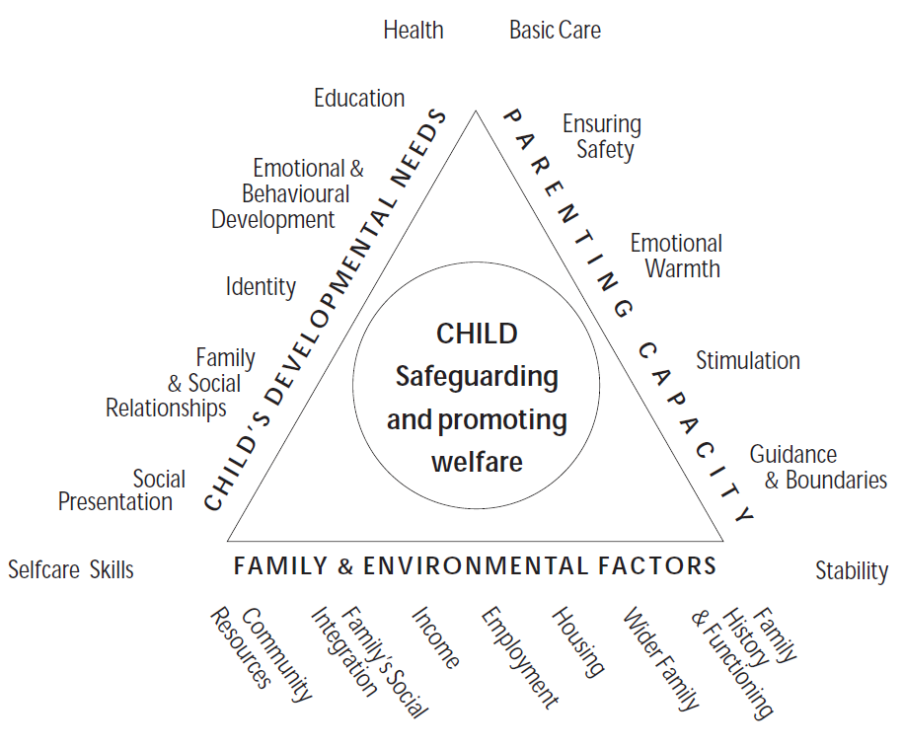
A child is brought by parents to all appointments and attends all meetings concerning the child.
This should be entered as strength.

Family and environmental factors

The family home is overcrowded and damp, and the parents have no recourse to public funds.
This should be entered as a complicating factor

Child’s Developmental Needs

Parents report that the child falls frequently thus causing lots of bumps and bruises. This has not been raised by them prior to the s.47 child protection enquiry. This should be entered as either a grey area (as it needs further assessment) or a current risk depending on the severity, frequency and location of the injuries, or can be entered under both.

As the previous example demonstrates, you may summarise the information into different categories, or sometimes in multiple categories at once. Do not get too concerned about whether you have placed the information into the right category as you may view the situation differently from that of others. What is important is that you ensure you capture all the salient points in your report. The conference Chair will summarise all information shared at the conference into the categories he or she deems most appropriate.

Submitting Your Report

Your report needs to be received by the conference team at least 3 working days in advance of the conference for the Chair to review and copies to be made.

Guidance for completing the INITIAL Child Protection Conference Report

The report has been designed to help professionals provide relevant written information to initial child protection conferences (ICPC). The information will also contribute to comprehensive risk analysis, decision making and planning for the children being considered at the ICPC.

The form asks for a lot of information, this is in order to ensure that the conference itself focuses on the key areas required for decisions, recommendations and the content of the outline child protection plan.

General things to consider when completing the report:

- The report should always be typed.
- Ensure that the primary focus of the report is the child/ren of the family and be clear with your comments which child/ren you are referring to. It can sometimes be difficult to share information with family members. However, research suggests that parents and other family members prefer an open, transparent approach from professionals. Additionally, such an approach is the most protective for children. If you have doubts about what should be included in the report, discuss it with your line manager or chair of the conference – contact details are on the report.
- You may believe that you have very little information to share, and there may be fields you can’t complete but include whatever information you do have, regardless of how minor/minimal you consider it to be.
- Allow sufficient time to complete the report and email it to: CPRU.rep@kirklees.gov.uk at Child Protection and Review Unit (CPRU) at least 3 working days prior to the conference. This will provide sufficient time for the report to be copied and considered by the chair. Please contact the CPRU by telephone on 01484 221000 if there are any issues with the report.
- Your report must be shared with parents/carers/children at least 3 working days prior to the conference. This helps active participation by the parents/carers in the conference process.
- At the conference be prepared to verbally summarise the key information in your report. This will also provide an opportunity to add any supplementary information, or update, you may have.
- Distinguish between fact and opinion.


Kirklees Multi-agency Child Protection Conference Report

Agency’s Name |  | DATE OF INITIAL

Professional’s Name |  | Professional’s Designation
Professional’s Address |  | Professional’s Contact Number
Social Worker’s Name |  | Social Worker’s Contact Number
GP’s Name |  | GP Surgery

Child(ren)’s Details (Please include any other names the child(ren) or significant adults are known by)
Forename | Surname |  | NHS Number | DOB | Address |  | Ethnicity |  | Disability or Special Need |  | School or Nursery
Details of Parents, Carers or Significant Family or Household Members
Forename | Surname | DOB |  | Address |  | Ethnicity |  | Disability or Special Need |  | Relationship to Child |  | PR?

 |  | Yes | No | Not known
First language of parent/carers?
Is a signer required?
Is an interpreter required?
Family faith/religious belief
Is additional support required? (e.g. literacy issues, learning disabilities etc.)
If Yes, please specify:
Has an Early Support Assessment been completed?
If Yes, name of Lead Professional and their agency:
Date of most recent Early Support Assessment:
Chronology of your agency’s significant events with child/family
Include factors relevant to your service such as:

- Purpose for your involvement
- Level of engagement and attendance
- Services or care provided
- Difficulties or challenges
- Referrals to other services
- Progress to date
- Duration of involvement
- Any actions outstanding

Current Risks or Concerns

Include what factors you consider to pose risk of significant harm or increase the risk of harm to the child/children?

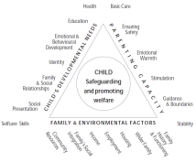

Historic or Complicating Factors

Include any previous history of concerns within the family, anything that might get in the way of resolving current risks and any previous involvement with your agency.

Safety / Protective Factors

Factors that you believe reduce the risks of harm to the child/children or help to ensure safety.

Strengths / Positives

Features of family life and parenting that have a positive effect on the children’s lives.

Grey Areas

This should incorporate any areas that are unclear or may be of potential concern for the child(ren) but require further time, clarity or assessment.

What do you believe to be the likely outcome for the child(ren) if their current situation continues?

What changes would you need to see in the family to assure you that the risk of harm to the children is sufficiently reduced?

What areas of risk or concern can your agency help the parents/carers to resolve?

Briefly describe what contribution your service can make to the child(ren)’s plan, who you could work with, and how you propose to undertake this work.

Report Completed By:
Author’s name |  | Designation
Signature |  | Date
Manager’s Name (if applicable) |  | Designation
Signature |  | Date

Has this report been shared with the parents/carers? |  | Has this report been shared with the child(ren)/young person?

What are the views of the parents/carers and/or the child(ren)/young person on this report?

