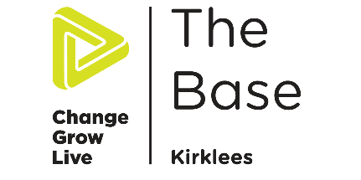
Groupwork/Professionals Request form
Huddersfield 01484 541589
Kate.ribchester@cgl.org.uk
Targeted Interventions Coordinator
Name and contact details: | Date requested: | Location/Agency:
No of people in group: | Subject wished to be covered: (Please Highlight)  General Drug and alcohol awareness  Cannabis Awareness  Alcohol Awareness  Party drugs and white powders  A-Z of Drugs box  Volatile substances  Festival safety  Nos  Lean and Xanax  Hidden Harm (Professionals only)  Other:
Staff Training: Y/N

Young Peoples Session: Y/N
No of sessions requested:
Preferred Date(s):
Preferred times of session(s): | Length of Sessions (Please Highlight):  1 hour 1.5 hours 2 hours 2+ Hours
Approximate ages of young people in group session: | Online Platform (Please Highlight):  Teams Skype Zoom
Any other details:
(Room arrangements, learning needs, triggers we should be aware off, specific drugs you would like to cover within the sessions etc)

