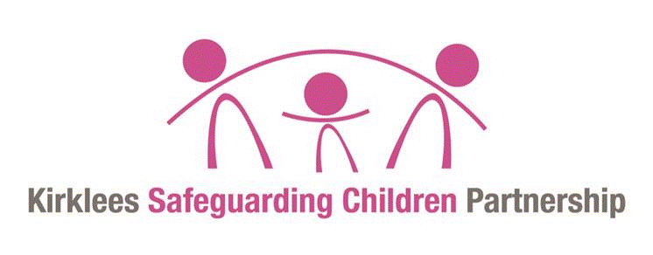
One minute guide
Honour Based Violence

What is Honour Based Violence?
Honour Based Violence (HBV) is a crime or incident committed to protect or defend the honour of a family and/or community.
There is not one specific crime; HBV generally occurs in domestic settings and can involve a range of offending behaviours which are used against individuals, families or other social groups to control and protect perceived cultural / religious beliefs and honour.
HBV may include murder, fear of or actual forced marriage, controlling sexual activity, domestic abuse (including psychological, physical, sexual, financial or emotional), child abuse, rape, kidnapping, false imprisonment, assault, harassment and forced abortion. This list is not exhaustive.
Such crimes cut across all cultures, nationalities, faith groups and communities. They transcend national and international boundaries; they are violations of human rights and there is no ‘honour’ in the commission of them.
HBV may occur when the perpetrator(s) perceive that a person (or persons) has shamed the family / community by breaking an honour code. The violence can include planning, premeditation and family /community conspiracy; often the belief held is that the victim(s) is ‘deserving’ of the punishment.

Who is involved?
Notions of honour framed within culture and religion are used for justification of primarily
(but not always) male violence against women and children. Justifications given for HBV may include: unapproved make-up or dress; having an unapproved girlfriend /boyfriend; intimacy in a public place; rejecting a forced marriage; pregnancy outside of marriage; being a victim of rape; inter-faith relationships; same-sex relationships; and / or leaving a spouse or seeking divorce.
HBV involving children means that they are at significant risk of actual physical harm, neglect and emotional harm through the threat of, or witnessing violence. Families may feel shame long after the incident that brought about ‘dishonour’ occurred; therefore the risk of serious harm to a child can persist.

What does the law say about this?
The Home Office definition of domestic abuse (2013), which Honour Based Violence is related to, now applies to young people aged 16 years and over.
Offences of Honour Based Violence are prosecuted under the specific offence committed e.g. common assault, grievous bodily harm, harassment, kidnap, rape and murder.

What should practitioners do? Awareness, disclosure and response
Practitioners should make themselves aware of potential signs of honour based violence. These include:
Children may go missing (from home and school) in an attempt to keep themselves safe;
Children may self-harm, appear depressed, angry and/ or desperate; Children may be restricted in their movements and overly supervised; Children might not have access to the internet, mobile phones, and their passport or family members; and / or
Children might be forced to marry, or forced to live elsewhere.
If a child tells a practitioner about honour based violence in respect of themselves or another family member, the practitioner should:
See the child alone in a safe and private place to obtain their wishes, views and feelings and explain confidentiality fully, including the need to share;
Record carefully; caution is required about how information is recorded and
shielded within the organisation to ensure the child’s safety; and
Should NOT make contact with the family or community leaders, and should not under any circumstances, tell the family or their social network about what the child has said, attempt mediation or use members of the community to interpret on behalf of the child.
If a child tells a practitioner about honour based violence, a referral must be made to the Children’s Services Duty and Advice Team, who in partnership with the Police may undertake a Section 47 Enquiry (safeguarding).
Practitioners should also be aware that children who are at risk of serious harm through child sexual exploitation, trafficking, forced marriage, honour based violence and female genital mutilation are often ‘hidden’ and may be also missing from education, and /or care or home.

Key contacts and more information
Duty and Advice Team tel: 01484 414960
Crown Prosecution Service - https://www.cps.gov.uk/
West Yorkshire Online Procedures — https://westyorkscb.proceduresonline.com/index.htm

