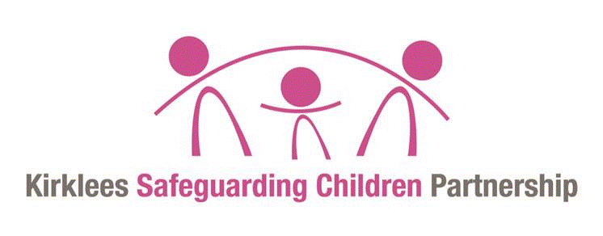
One minute guide
Absent, Missing and Away from placement
without authorisation

What do ‘Absent’, ‘Missing’ and ‘away from placement without authorisation’ mean?

A ‘Missing’ child is a child under the age of 18 whose:

whereabouts cannot be established and
where the circumstances are out of character, or
the context suggests the child may be subject of crime or at risk of harm to themselves
or another.

And whose family or carers have reported them as missing to the police.

An ‘Absent’ child is:

A child who is not at a place where they are expected or required to be and
there are no concerns regarding their welfare.

For children looked after there is another category which is ‘away from placement without
authorisation’. This relates to:

Children looked after by the local authority, whose whereabouts is known, but who is
not at their placement or place they are expected to be (absent) but for who the carer has concerns or the incident has been notified to the local authority or the police.

Which children and young people are we talking about?

Children and young people absent themselves from living with their parents at home and from care (looked after children).

Some of the children and young people living at home with their parents are currently known to Children’s Social Work Service and others are not.

Link to Child Exploitation
Practitioners should be aware that when a young person repeatedly goes missing, this may be an indicator that they are at risk of child exploitation (CE). In addition, children and young people who go missing are also more vulnerable to exploitation. Professionals must be aware of the indicators of child exploitation and follow the Kirklees MACE procedures.

Or for more information, follow the link to West Yorkshire Safeguarding Procedures https://westyorkscb.proceduresonline.com/index.htm

If a child is missing or absent what should be done?

Parents and carers should take all reasonable and practical steps to establish the whereabouts
and well-being of a child in order to identify whether the child is absent or missing

For both absent and missing children, all details about the absence should be recorded including any steps taken to locate and return the child. Information should be shared with key people throughout the absent or missing period such as the family/carer, the Police and the social worker (or Emergency Duty Team).

If there are concerns about a child being absent or away from placement, the child should be reported as missing to the police; the police should be provided with details of steps taken to locate and return the child; child’s details including photo and physical description / clothes worn; where and when last seen; and if there are any other risk factors such as CE or learning disability.

Where a child is absent or away from placement without authorisation the situation should be reviewed at least every eight hours. Regardless of the level of risk, all absences should be upgraded to missing if they continue for 72 hours.

Where the child is absent or away from placement without authorisation and there are immediate risks identified, although the location is known, contact should be made with the police to discuss.

Safe and Well checks and Return Interviews

On return, every child who has been reported as missing, should have a Safe and Well check carried out by the Police. Within 72 hours of a child’s return a more in depth Return Interview arranged by the local authority should be undertaken and where a child is either looked after, subject to a child protection or a child in need plan, social workers should consider the need for a Missing Risk Management meeting referrral
Where a child who has been missing does not currently have social work involvement, the police, family or other practitioners should consider whether a referral to the children’s services Font Door team is required.

Who are the key contacts and more information?

Front Door to CSC Tel: 01484 414960
or out of hours Emergency Duty Team Tel: 01484 414960

Police Tel: 999 for emergencies, 101 for non-emergencies

