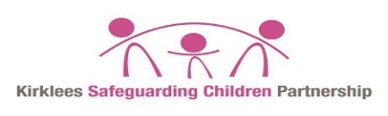

**Professional disagreement/escalation process for ANY child residing in Kirklees**

**Framework for Decision Making**

No Immediate risk

Discuss concern with line manager agreeing a timescale for follow up

Discuss concerns with agency/ to try and informally resolve issue

Immediate Significant Risk

Safeguarding lead/manager to discuss with safeguarding lead in other agency

Unresolved

Refer to Head of Service within the service within 5 working days

Put into writing within 5 days as a challenge to agency with whom you have a disagreement of decision. Record and copy in your safeguarding lead/manager

Duty & Advice

Professional Number 01484 414960

OR

**999**

Decision making/feedback from D&A to referring agency with actions and decisions

Resolved No Further Action

Refer to KSCP manager to determine action including reporting to Independent Chair for resolution

Refer to Service Manager within the service within 5 working days

Resolved No Further Action