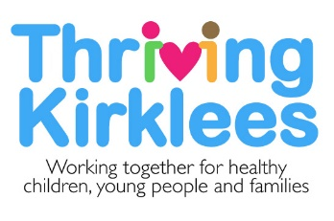

Thriving Kirklees

Service Offer for Families and Young People
Information for Community Hubs

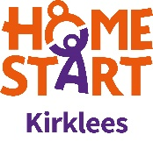
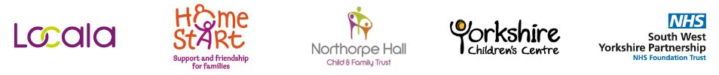
Locala 0-19 Service

Getting advice and Signposting
- Healthy Child Programme Core contacts:
  - Antenatal - between approximately 32 and 36 weeks gestation - Face to face
  - Birth visit - before 28 days - Face to face
  - 6-8 week assessment - Telephone or face to face contact dependant on need
  - Immunisations at 8, 12 and 16 weeks - clinic or GP
  - Pre One year assessment - Appointment to a clinic setting, unless a targeted family.
  - Immunisations at 12 and 13 months
  - Two year assessment - Appointment to a clinic setting, unless a targeted family. Children in an Early Years Setting (EYS) will be assessed by EYS in some areas.
  - Immunisations at 3 years and 4 months
  - Reception year health assessment and National Child measurement Programme (NCMP) - Face to face height and weight. Assessment via questionnaire and interventions response indicates additional need.
  - Year 6 NCMP- Face to face height and weight.
- Aiding in implementing school guidance for children with medical conditions
- Nurturing Parents - Preparation for Parenthood course - 6 week programme available to all “parents to be”.
- Community Clinics - https://www.locala.org.uk/your-healthcare/health-visiting/clinic-information-and-times/
- Chat health - Text service for advice and support. Two lines, one for young people 07520 618866 and one for parents and carers 07520 618867.

Getting Help
- First line interventions, care pathways:
  - Healthy lifestyle and healthy eating advice
  - Behavioural support – including sleeping, potty training and temper tantrums
  - Emotional support with any aspect of parenting including postnatal depression, violence within the family and bereavement.
  - Helping parents and young people to improve their emotional health and wellbeing, self-esteem, anxieties, low mood.
  - Sexual health advice and support
  - Drug and alcohol misuse
- Telephone advice, self-help strategies, signposting to other services.

Getting Risk Support
- Safeguarding- attending case conferences, core groups, health interventions with the Family
- Looked after children health assessments. Every 6 months to under 5 year olds and yearly for 5-19 year olds.
- Nurse advisors for Looked after children, Pupil Referral units and Youth offending team.
(Note: The Italics above are services not part of Thriving Kirklees but provided by Locala for children in the cohort)
ChEWS @ Northorpe Hall

ChEWS (Children’s Emotional Wellbeing Service) at Northorpe Hall delivers Child and Adolescent Mental Health Services alongside South West Yorkshire Partnership NHS Foundation Trust (SWYPFT) in Kirklees as part of the Thriving Kirklees partnership.

What do we offer for Education Provisions?
Do you need some support and advice?

Contact with Wellbeing Support Workers over the phone to provide quick support and advice relating to individual children and young people’s emotional and mental health - 0300 304 5555 or online at www.thrivingkirklees.org.uk

Do your staff need upskilling?
- Targeting whole school/hub audience. We offer 1 hour 30 minute sessions. (Minimum participants 15 Primary, 30 Secondary):
- Introduction to Children and Young Persons Mental Health – Provides a general overview of mental health across the spectrum, risk and resilience, ideas for promoting an emotionally healthy classroom.
- Understanding Attachment Theory - Provides an introduction to theories of attachment, how attachments impact on students and our own behaviour, guiding principles when supporting.
- Introduction to Self-Harm – Understanding why young people self-harm, and how we can positively support them to find healthier coping strategies. Dispelling myths, dos and don’ts.
- The Teenage Brain – A brief look into what causes the behavioural changes in teenagers, and what we can do to support them positively.
- Maintaining Positive Emotional Wellbeing – An overview of ideas to support and maintain positive emotional wellbeing. Can be used in our work with young people, or applied to staff wellbeing.

We offer 2 hour sessions:
- Understanding Behaviour as Communication – An overview of internal and external drivers of behaviour, ideas of how to support challenging young people, self-care and resource sharing.
- Understanding and Supporting Anxiety – A brief look into the underlying causes of anxiety, including factors that maintain anxiety. Treatments and approaches, coping strategies. Strong focus on normalising worry/nerves/anxiety.

Targeting Emotional Wellbeing Leads, Support Staff and Pastoral Care. We also offer up to 1 hour 30 minute sessions. (Minimum participants 6 Primary, 12 Secondary):
- Mental Health Services/Pathways in Kirklees
- Making Appropriate Referrals
- Resource Sharing- We are happy to share a wide range of resources with staff via email or face to face.
- Reflective Peer-to-Peer Supervision Model for staff
What’s on offer for Emotional Health and Wellbeing Leads?
- Emotional Well Being Lead Network Meetings held three times a term at Northorpe Hall
- Half Termly Newsletter emailed to EWB Leads and assistant Leads
- One-to-one consultations to education provisions (this could look at whole school approach to emotional health, internal support systems, staff support etc.)

*Moodmaster sessions are evidence based sessions developed by APT. The sessions cover a variety of different topics to teach young people the skills necessary to maintain positive mental health.
To book to be a Host School for Young People’s Workshops, contact: jade.taylor@northorpehall.co.uk

If you have made a support request for a child or young person, we may offer one of the following interventions:
- Focused Group Work Interventions:
- Anxiety
- Low Mood
- Timid To Tiger
- Telephone Support
- Direct 1:1 Interventions
- Access and initial assessment for Neurodevelopmental pathway
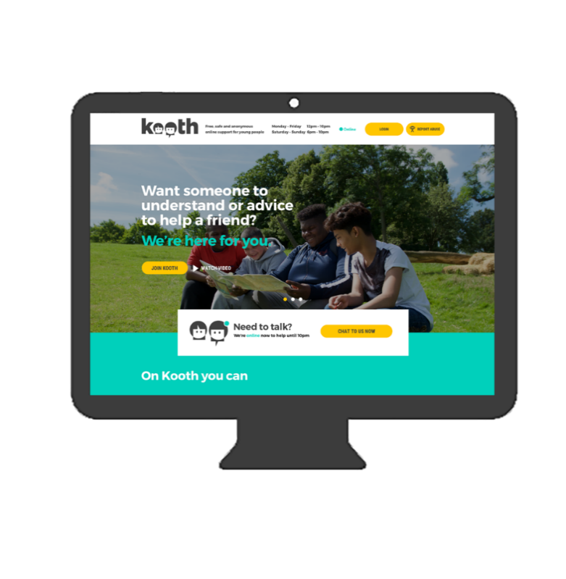
Kooth
Kooth is a free, online counselling and emotional wellbeing platform for young people in Kirklees aged 11 to 19 (you can use Kooth until you turn 20 yrs old).
The Kooth website allows young people to gain anonymous access to advice, support and guidance on any issue that is affecting their wellbeing. From friendship or relationship issues, family disagreements or difficult home lives, to concerns around eating, anxiety, stress, depression, self-harm, suicidal thoughts etc.
Qualified counsellors are available to give young people the support they need, when they need it. Kooth.com’s live chat service is available from Monday to Friday 12 noon - 10pm, Saturdays and Sundays 6pm - 10pm and is accessible through mobile, tablet and desktop, completely free of charge.
Access via the website www.Kooth.com

SWYPFT Specialist CAMHS

The first priority of our South West Yorkshire Partnership Foundation NHS Trust (SWYPFT) CAMHS Service is the emotional wellbeing of the children, young people, and families who are accessing our service.

Our CAMHS team work hard at building positive relationships with children and young people during such a challenging period in their lives. The coping strategies and self-management techniques used by our CAMHS team ensure that children can live life to their full potential

Service Description

Thriving Kirklees CAMHS (SWYPFT) will be provided for the most severe, complex and persistent of child mental health problems/disorders; and risk factors which have multi-factorial causation.

We deliver specialist services; including assessment, consultation, diagnosis, formulation and intervention. In delivering these services, we will adopt the Care Programme Approach Framework of Assessment, Care Planning and Review for all children and young people.

We will work with children and young people under the age of 18 years, however, for those young people who have Special Educational Needs, a service will be offered up until the age of 19 years, as per the service specification.

Thriving Kirklees CAMHS (SWYPFT) offers assessment and interventions to children and young people who present with persistent and significant difficulties with the following:

- Depression (where severe or they have not responded to earlier intervention)
- Self-harm and suicide attempt
- Severe anxiety (including obsessive compulsive disorder)
- Eating disorders with significant risk or impairment (such as anorexia nervosa or bulimia)
- Psychosis (in those aged under 14)
- Somatoform disorders
- Neuro developmental disorder assessments
- Prolonged adjustment difficulties eg abnormal grief reactions
- Persistent post-traumatic disorder (PTSD)
- A range of neuropsychiatric conditions (including Tourettes syndrome)
- Learning Disability
- Autistic spectrum conditions (at appropriate times)

Our aim is to improve the mental health of individuals accessing our service, and we work closely with other Trust and community services to ensure the needs of the individual are best met.

We work alongside other organisations; including Children’s Social Care, Children’s Health and Wellbeing services, Schools, School Nurses, and other community-based organisations.
Home-Start Kirklees

Volunteer home-visiting support
(for any families in Kirklees with a child under 5 years not yet in full time education)
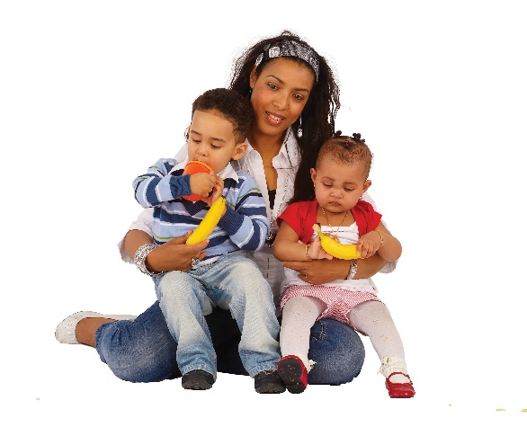
Families referred to Home-Start Kirklees are offered a trained volunteer to support weekly by visiting the family in their home for 2-3 hours. Volunteers can offer practical help and emotional support to parents who maybe need someone to talk to and are feeling low due to issues that any family can face.
Volunteers are carefully matched to families and offer support for as long as it is needed, as long as the youngest child in the home is under 5 years old and not in full time education.
Home-Start Co-ordinators supervise the volunteers and keep in touch with families to ensure that they receive the right support. They review the family’s needs every three months.
Home-Start support is confidential and is tailored to meet the needs of individual families. Parents choose to have Home-Start support and can either self-refer or can be referred by a professional who is already supporting the family.
Weekly group support for young parents (14-24 years)
Home-Start Kirklees offers group support for young parents aged 14-24 years. Group sessions run weekly and all the parents and children who attend eat a healthy lunch together before playtime for the children and much needed social time for the parents. Group sessions are delivered by Home-Start staff and supported by volunteers and peer educators. Our young parents can decide and design the themes of the group sessions and chose the range of activities provided.
Peer Educator support (group support and 1 to 1 support for young parents)
Peer supporters have been young parents themselves and have first-hand experience of some of the difficulties and challenges young parents face. Peer supporters have undergone specific Home-Start training and are keen to help other young parents individually or in group support sessions. This is a volunteer role open to anyone with relevant experience.
Affordable warmth
Home-Start families are assessed at initial visit to determine whether they require essential items to keep themselves warm in the winter season. Home-Start will provide new items of duvets, bedding, coats, hats, scarves for the children and curtains etc. should the family have no means to provide for themselves which would leave them vulnerable in the colder months.
Yorkshire Children’s Centre

Safety in the Home Service

Eligible* families living in Kirklees with children under 2 years old are provided with free home safety equipment, which is fitted in their home. The safety equipment supplied includes: safety gates, fire guard, bath mat, cupboard locks, corner cushions, blind cord winders and window restrictors.
Families also receive:
- a free home fire safety check
- new smoke detectors fitted where required
- child accident prevention and home fire safety information and advice

*To be eligible families must live in Kirklees, have a child under 2 years old and be in receipt of benefits, or be on a child in need/protection plan. For the full list of eligibility criteria please visit http://yorkshirechildrenscentre.org.uk/our-services/support-for-families/safety-home/

Safety Rangers
Year 5 primary school children from schools in areas of high deprivation in Kirklees attend Safety Rangers at Huddersfield and Dewsbury Fire Stations. The aim is to reduce and prevent childhood accidents, and improve child health and wellbeing through a variety of interactive, fun teaching methods and scenarios.

Topics covered include home and seasonal fire safety, road safety, anti-social behaviour and emotional health and wellbeing. The scenarios are delivered by our partners - West Yorkshire Fire and Rescue Service, Kirklees Council Road Safety Team, West Yorkshire Police, South & West Yorkshire Partnership Foundation Trust & Northorpe Hall. Safety Rangers runs four times a year for one week, and the children attend for half a day.

Healthy Start
‘Healthy Start’ is a statutory Government scheme and is designed to provide financial help to improve the nutrition of families receiving certain benefits. Qualifying pregnant women and families with young children are provided with vouchers which can be used to buy milk, fresh fruit and vegetables and infant formula. Qualifying families will also be entitled to free maternal supplements and/or child vitamin drops.

Yorkshire Children’s Centre (YCC) ensures that qualifying families can easily exchange their vouchers for vitamins in Kirklees from various distribution centres.

(See next page for qualifying criteria)

How do families qualify for Healthy Start?
- If you’re at least 10 weeks pregnant or have a child under four years old and you or your family receive:
- Income Support, or
- Income-based Jobseeker’s Allowance, or
- Income-related Employment and Support Allowance, or
- Child Tax Credit (with a family income of £16,190 or less per year), or
- Universal Credit (with a family take home pay of £408 or less per month)
- You also qualify if you are under 18 and pregnant, even if you don’t get any of the above benefits.

For further information on the qualifying criteria, families are advised to visit the following web address: http://yorkshirechildrenscentre.org.uk/our-services/support-for-families/healthy-start/ Families can complete a short questionnaire to find out instantly if they qualify.
For information on the application process please contact National Healthy Start Scheme on Tel: 0345 607 6823. Families that are eligible can collect their vitamins from various distribution centre across Kirklees – the location of these can be found by visiting the Yorkshire Children’s Centre website - http://yorkshirechildrenscentre.org.uk/our-services/support-for-families/healthy-start/

Child Accident Prevention

YCC leads on child accident prevention work within the Thriving Kirklees partnership. Current work relates to upskilling 0-19 professionals, schools, and even families themselves, on how to prevent childhood accidents.

YCC and Kirklees Safeguarding Children’s Board (KSCB) work in partnership to provide free Child Accident Prevention E-Learning, which is on the KSCB website (www.kirkleessafeguardingchildren.co.uk).
This E-Learning course enables professionals, parents and carers to:
- Identify risks in the home and elsewhere that are the common causes of accidents for children
- Describe steps you are able to take in order to reduce the risk of a child having an accident
- Make, or support families to make, changes to keep children safe

** Please note this E-Learning package is currently being re-designed - we expect to have the new training rolled out by the end of 2019*
Contacts

To request support for families and young people: -
Thriving Kirklees website www.thrivingkirklees.org.uk
Or telephone SPoC (Single Point of Contact) 0300 304 5555 (available 24 hours a day, 7 days a week.

