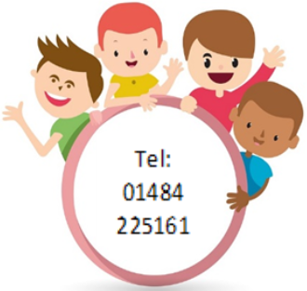
Early Support Guidance
A  Early Support overview and strategy | A Early Support overview and strategy | B  Early support referral and assessment process
 | B Early Support referral and assessment process
C  Early support Panel guidance | C Early support Panel guidance | D Early Support pathway flowchart
 | D Early Support pathway flowchart
E  Membership and TOR for Early Support Panel | E Membership and TOR for Early Support Panel | F  Panel agenda pro forma
 | F Panel agenda pro forma

