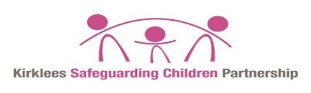

Professional disagreement/escalation process for ANY child residing in Kirklees
Framework for Decision Making

No Immediate risk
Immediate Significant Risk

Safeguarding lead/manager to discuss with safeguarding lead in other agency
Unresolved
Refer to Head of Service within the service within 5 working days
Put into writing within 5 days as a challenge to agency with whom you have a disagreement of decision. Record and copy in your safeguarding lead/manager
Duty & Advice
Professional Number 01484 414960
OR
999
Decision making/feedback from D&A to referring agency with actions and decisions
Resolved No Further Action
Refer to KSCP manager to determine action including reporting to Independent Chair for resolution
Refer to Service Manager within the service within 5 working days
Resolved No Further Action

