Safeguarding Checklist
A Self Assessment Tool for the Voluntary and Community Sector

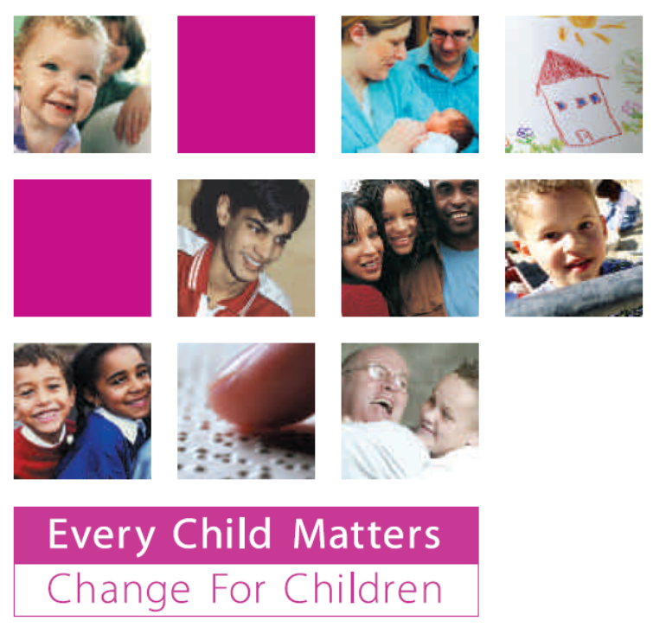
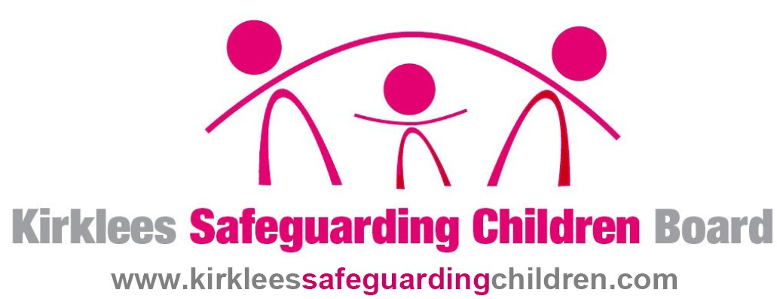

This is an opportunity for your organisation to look at your safeguarding practice and find out where to go for help and support.
You are not expected to have everything listed in place.
You will be encouraged and supported to work towards these safeguarding requirements.

Introduction: What is safeguarding?
Any organisation offering activities to children and young people has a legal and moral duty to safeguard the children and young people with whom it works. This means doing everything we can to reduce the risk of a child coming to harm while in our care, and knowing what to do if we believe the child to be suffering from harm caused outside our setting.

Does it apply to me?
Safeguarding applies to every group that has any contact with children or families, however infrequent. It is not just for organisations providing childcare. Even if you only run one event a year to which children and their families are invited, you still have a responsibility to ensure your event is safe and that children are protected from harm.

Why should we use this safeguarding checklist?
A safe activity is a well-managed activity. We only reduce risk through good, safe management, and this means following best practice in all areas of work.

The safeguarding checklist looks at those factors that are recognised as essential in ensuring good practice in safeguarding. The purpose is to help your group:

- Assess current safeguarding practice
- Identify concerns and areas for improvement
- Identify the support you may need to make these improvements

How to use the Safeguarding Checklist
Read the questions in the table below and answer as honestly as you can. You will not be judged on your answers. The aim of this checklist is to help you learn more about the best practice expected around safeguarding and to help you make any improvements necessary.

Once you have worked through the questions, and identified any areas for development, you should then complete the Action Plan at the end of this document to make sure it is clear who will make these improvements and when they should be completed.

What happens after the checklist is completed?
You are encouraged to make the improvements you have identified in your action plan. You may feel able to do this on your own, or you may feel you require more support. You are welcome to contact KSCB at any time for this support, you can email KSCB.Admin@kirklees.gov.uk or call 01484 225161.

Please send your completed checklist to KSCB, 3rd Floor Somerset Buildings, 10 Church Street, Huddersfield, HD1 1DD for feedback and a personalised guide of what to do next. All KSCB services and support to the voluntary and community sector are free of charge. We must stress again that you are not judged on your answers and there are no consequences to not having any safeguarding requirements in place. The aim of the checklist is to help you identify the gaps and work to address them. If you have any queries please do not hesitate to contact us.

Name of your organisation:

QUESTION | YES/NO | ANSWERS to further questions | What improvements could you make? | What support do you need to do this? (This could be written or online information, information briefings, training, one to one support for your groups etc)
Safeguarding Essentials
Do you have a Safeguarding Policy?

Does this include:
A statement about your commitment to safeguarding
A statement about your commitment to safeguarding training
Confidentiality & information sharing (including when to share concerns about a child with other agencies)

Record keeping
Clear definitions of what constitutes Child Abuse
Relationship to other relevant policies (eg recruitment, screening, supervision, health & safety, volunteering, whistleblowing, promoting diversity etc). If your organisation does not have these other policies, it will need to include these safeguarding aspects in this policy.
Do you have a designated person to take the lead on safeguarding issues (usually called the Child Protection Officer, Safeguarding Officer, Child Welfare Officer etc)?

QUESTION | YES/NO | ANSWERS to further questions | What improvements could you make? | What support do you need to do this? (This could be written or online information, information briefings, training, one to one support for your groups etc)
Do you have Safeguarding procedures?

Do your Safeguarding procedures make it clear what you will do:
When a child discloses

When you observe signs and symptoms that give cause for concern

When you observe the practice of a colleague that gives you cause for concern/receive a complaint about a member of staff

Do you know what to do if you had concerns about a staff member or an allegation was made?

Do you have a Code of Conduct? (a statement of what behaviour is appropriate and what is inappropriate for members of staff)

Safer recruitment

Do you have a written Safe Recruitment policy and procedure?

Do you ensure all those working with children have current CRB checks?

Has someone in your organisation received training on Safer Recruitment?
QUESTION | YES/NO | ANSWERS to further questions | What improvements could you make? | What support do you need to do this? (This could be written or online information, information briefings, training, one to one support for your groups etc)
Involving your communities

How do you make sure everyone in your organisation is aware of all your policies and procedures relevant to safeguarding and understand how they are expected to act?

How do you make sure new staff or volunteers are made aware of safeguarding practice?

Are there support and accountability mechanisms in place for staff and volunteers

How does your organisation keep up to date on safeguarding issues?

Supporting families

If you identified a child or families with additional needs would you know how to access other support?

QUESTION | YES/NO | ANSWERS to further questions | What improvements could you make? | What support do you need to do this? (This could be written or online information, information briefings, training, one to one support for your groups etc)
Wider safeguarding issues

Do you have health & safety procedures for your activities with children & young people?

Do you have a Supervision of Children and Young People policy for your activities? This should highlight adult to child ratios, preparing for emergencies etc

Do you have any guidance on how to manage children and young peoples behaviour?

Record Keeping - does the organisation have a system to record child protection concerns and actions, existing injuries etc?

Do you have a Complaints Procedure?

Do you have an E-safety Policy?
(this can be to cover the use of staff and young peoples use of the internet, mobile phones, cameras and all other digital equipment)

Management responsibilities around safeguarding

Do you have a management committee / board of trustees?
Does your management committee / board of trustees know what its legal responsibilities and duties are regarding safeguarding?

How are they made aware?

Do you have role descriptions for everyone on the committee?

Do these role descriptions outline safeguarding responsibilities?

SAFEGUARDING ACTION PLAN

List below the steps you can take to improve your safeguarding practice. Use the table to help you allocate responsibility for making sure these improvements take pace. Be realistic about the time scales you set to achieve these improvements.

Action | By Who | By When | Review date

Signed off by: Name (in print):
Position in Organisation:
Date:
Date to review:

Information and websites to help you

www.kirkleessafeguardingchildren.com
A whole range of information and free online training for all staff and volunteers. You will also find the procedures for dealing with any concerns you have on any issues around child protection and guidance specifically written for the VCS

www.voluntaryactionkirklees.co.uk

For a wide range of issues and support to the voluntary and community sector in Kirklees

http://www.charity-commission.gov.uk/supportingcharities/protection.asp#4
This web site contains information on child protection or “safeguarding” with good links to other web sites

www.teachernet.gov.uk/visits - contains HASPEV (Health & Safety for Pupils on Educational Visits) the government guidance on how to manage activities for children safely. Although written for schools it provides the benchmark for best practice in health & safety all should follow.

www.safenetwork.org.uk
Guidance to the VCS from Children England and the NSPCC on keeping children safe from harm.

www.barnardos.org.uk
Useful resources for practitioners, students and teachers as well as information on internet safety and training opportunities
http://www.nspcc.org.uk/helpandadvice/communitygroups/communitygroups_wda36495.html
Providing a wide range of services and supporting products to help voluntary and community groups working with children

www.ncvcco.org
Provides useful books and leaflets including ‘Positively safe: a guide to developing safeguarding practices’

www.ncvys.org.uk
Provides the Keeping it Safe toolkit and Sound Systems (the accreditation scheme from the National Council Voluntary Youth Services)
http://www.isa-gov.org.uk/ http://www.crbdisclosure.org.uk http://www.cwdcouncil.org.uk/safeguarding/safer-recruitment http://www.crb.gov.uk
For information on safer recruitment for staff and volunteers

www.sportscoachuk.org
Sports Coach UK (formerly National Coaching Foundation): some excellent publications and training available to help sports groups with child protection issues.

www.dfes.gov.uk/publications.childrenactreport/
Information on statutory duties under the Children Act 2004. Voluntary and Community Sector – Chapter 2 (2.145-2. 155) pages 71-73

www.childnet-int.org
Guidance around internet access and safety.

www.ceop.gov.uk
Guidance for parents, carers and professionals in understanding and safeguarding what young people do on line, with mobile phones etc

www.rospa.com
Information relating to accident prevention including a guide on Minibus Safety visit

http://hbr.nya.org.uk/
Hear by Right offers tried and tested standards for organisations to improve their practice and policy on the participation of children and young people.

www.kidscape.org.uk
Contains excellent resources and training around bullying.

www.nch.org.uk
Contains some useful general information and some specific guides directed at young people for safe use of the internet. Look under their Information heading.

www.arunet.co.uk
This gives excellent support around play-work issues offering leaflets and policy documents as well as up to date news and information. Ideal for any organisation offering play activities with children

Other Essential Reading (all available on line)
Working Together to Safeguard Children The United Nation's Convention on the Rights of the Child (UNCRC) The Common Assessment Framework
Disability Act 2005 Information Sharing: “Guidance for practitioners and managers”

