

Kirklees Multi-Agency REVIEW Child Protection Conference Report

Guidance for Completing This Report
This report format has been designed in consultation with partner agencies to fit the format for child protection conferences in Kirklees. It is to be used by professionals to provide relevant information on the children and young people they are working with to be shared at both initial and review child protection conferences.

Please write the report based on your professional knowledge and understanding of the child(ren) and family. As this is a generic form you must ensure pertinent information from your agency or specialism is included. You need only to complete one report for all the relevant family members that you are working with.

You may wish to refer to the Assessment Framework triangle to aid you assessment. For further information click this link. Some examples of how the triangle can assist completing the five sections are:
Assessment Framework

Parenting capacity
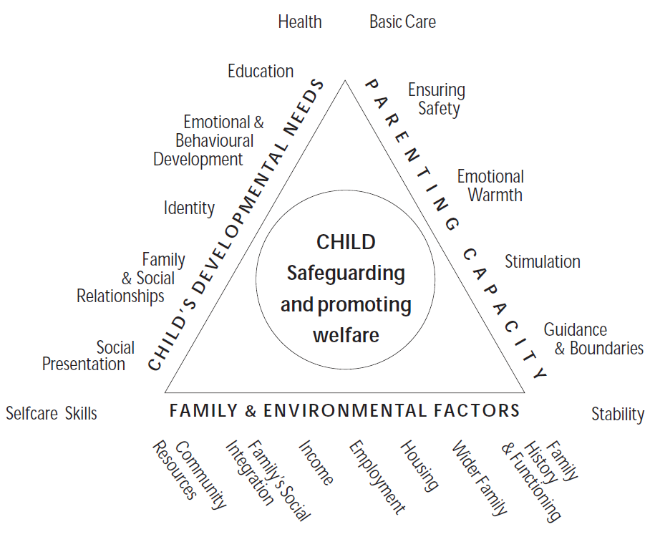
A child is brought by parents to all appointments and attends all meetings concerning the child.
This should be entered as strength.

Family and environmental factors

The family home is overcrowded and damp, and the parents have no recourse to public funds.
This should be entered as a complicating factor.

Child’s Developmental Needs

Parents report that the child falls frequently thus causing lots of bumps and bruises. This has not been raised by them prior to the s.47 child protection enquiry. This should be entered as either a grey area (as it needs further assessment) or a current risk depending on the severity, frequency and location of the injuries, or can be entered under both.

As the previous example demonstrates, you may summarise the information into different categories, or sometimes in multiple categories at once. Do not get too concerned about whether you have placed the information into the right category as you may view the situation differently from that of others. What is important is that you ensure you capture all the salient points in your report. The conference Chair will summarise all information shared at the conference into the categories he or she deems most appropriate.

Submitting Your Report

Your report needs to be received by the conference team at least 2 working days in advance of the conference for the Chair to review and copies to be made.

Guidance for completing the REVIEW Child Protection Conference Report

The report has been designed to help professionals update their information, take part in the ongoing risk analysis, make decisions on whether to continue or discontinue the child protection plan, and where appropriate update the child protection plan.

Things to consider when completing the report:
- The report should always be typed.
- A separate report should be submitted by each professional member of the core group.
- Ensure that the primary focus of the report is the child/ren of the family, applying an honest, open approach – always be clear which child/ren you are referring to.
- Allow sufficient time to complete the report and email to: cpru.reports@kirklees.gcsx.gov.uk the Child Protection and Review Unit (CPRU) 2 working days prior to the conference. This will allow sufficient time for the report to be copied and considered by the conference chair. Given that this is a child protection review conference, with the date agreed at the previous conference, there should be no reason not to submit the report to CPRU in good time. Please contact the CPRU on 01484 221000 if there are any issues with submitting the report.
- Additionally, your report must be shared with parents/carers/children at least 2 working days prior to the conference. This helps active participation by the parents/carers in the child protection process. Given that this is a review conference, there should be no reason why the report is not shared with parents/carers in good time.
- Be prepared to summarise the key information in your report during the review conference.
- Distinguish between fact and opinion.

Specifics of the report:
- This report should update the information held in previous reports. You will be sent a composite basic information/front sheet – if you need to amend/update this use a different colour font to indicate where you have made the amendments.
- Use the chronology section to outline significant events you think the conference should be aware of eg attendance or non-attendance at appointments, home visits etc.
- The main focus of this report is the process of reviewing the previous assessments of risk/signs of safety and identifying changes to any of the headed boxes – see Strengthening Families Framework guidance below.
- It will be your responsibility in the light of the information shared at Conference to actively contribute to the joint decision as to whether a child protection plan is still necessary or if a child in need plan or CAF should be considered.
Kirklees Multi-Agency REVIEW Child Protection Conference Report

Agency’s Name |  | DATE OF REVIEW
Professional’s Name |  | Professional’s Designation
Professional’s Address |  | Professional’s Contact Number  & Fax Number
Social Worker’s Name / Contact |  | Professional’s E-mail Address
GP’s Name |  | GP Surgery

Child(ren)’s Details
Forename | Surname |  | NHS Number | DOB | Address |  | Ethnicity |  | Disability or Special Need |  | School or Nursery
Details of Parents, Carers or Significant Family or Household Members
Forename | Surname | DOB |  | Address |  | Ethnicity |  | Disability or Special Need |  | Relationship to Child |  | PR?

 |  | Yes | No | Not known
First language of parent/carers?
Is a signer required?
Is an interpreter required?
Family faith/religious belief
Is additional support required? (eg literacy issues, learning disabilities etc)
If Yes, please specify:

To achieve improved outcomes for this child, should services be provided as part of:
Child Protection Plan
Child in Need Plan
CAF
No Plan/other (state)

This report must be shared fully with the parents and child(ren) before the Conference, unless you believe this will place any person at serious risk of harm.

A copy of this report must be provided to the relevant Team Manager and Conference Chair at least 2 working days prior to the Conference.

Please fill in the attached chronology if you are able to.

Continued Chronology of your agency’s significant events with child/family
Include factors relevant to your service such as:  - Purpose for your involvement  - Level of engagement and attendance  - Services or care provided  - Difficulties or challenges  - Referrals to other services  - Progress to date  - Duration of involvement  - Any actions outstanding  GUIDANCE NOTES:  Please provide dates along with a brief description of significant events. This should include any injuries to the child, incidents of domestic abuse, failed appointments etc. Concentrate on events which will inform the Conference about the risks and protective factors for the child.  All recorded events must be factual.  Please be clear which child(ren) the events refer to. | DATE | EVENT

Current Risks or Concerns

Include what factors you consider to pose risk of significant harm or increase the risk of harm to the child/children?

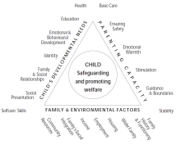

Historic or Complicating Factors

Include any previous history of concerns within the family, anything that might get in the way of resolving current risks and any previous involvement with your agency.

Safety / Protective Factors

Factors that you believe reduce the risks of harm to the child/children or help to ensure safety.

Strengths / Positives

Features of family life and parenting that have a positive effect on the children’s lives.

Grey Areas

This should incorporate any areas that are unclear or may be of potential concern for the child(ren) but require further time, clarity or assessment.

What do you believe to be the likely outcome for the child(ren) if their current situation continues?

What changes would you need to see in the family to assure you that the risk of harm to the children is sufficiently reduced?

What areas of risk or concern can your agency help the parents/carers to resolve?

Briefly describe what contribution your service can make to the child(ren)’s plan, who you could work with, and how you propose to undertake this work.

Report Completed By:
Author’s name |  |  |  |  | Designation
Author’s Job Title |  |  |  |  | Fax Number
Signature |  |  |  |  | Date
Length of Involvement With Family
(including start and end date, if applicable)
Discussed with Manager? | Yes | No | Not Applicable | Other (to specify)
Manager Comments:

Manager’s Name (if applicable) |  |  |  |  | Designation
Signature |  |  |  |  | Date

Has this report been shared with the parents/carers? |  | Has this report been shared with the child(ren)/young person?

What are the views of the parents/carers and/or the child(ren)/young person on this report?

