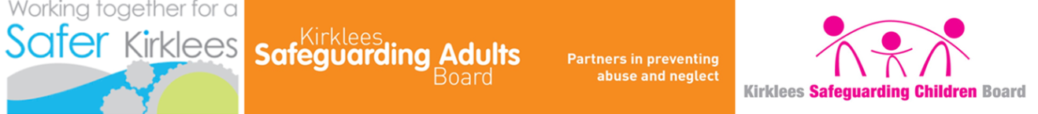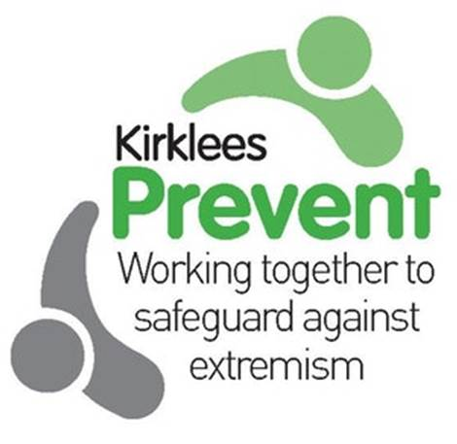

The Prevent strategy is part of an overall counter-terrorism strategy called CONTEST.

The purpose of Prevent is at its heart to safeguard and support vulnerable people to stop them from becoming terrorists or supporting terrorism. Our Prevent work also extends to supporting the rehabilitation and disengagement of those already involved in terrorism. Prevent works in a similar way to programmes designed to safeguard people from gangs, drug abuse, and physical and sexual abuse. Success means an enhanced response to tackle the causes of radicalisation, in communities and online; continued effective support to those who are vulnerable to radicalisation; and disengagement from terrorist activities by those already engaged in or supporters of terrorism.

The objectives of Prevent, as outlined in the 2018 strategy, are to:

* Tackle the causes of radicalisation and respond to the ideological challenge of terrorism.
* Safeguard and support those most at risk of radicalisation through early intervention, identifying them and offering support.
* Enable those who have already engaged in terrorism to disengage and rehabilitate.

# The basics

A collaborative piece of work produced by Kirklees Safeguarding Adults Board (KSAB),

Kirklees Safeguarding Children Board (KSCB) and Community Safety Partnerships (CSP)

Read the

[Prevent duty guidance](https://www.gov.uk/government/publications/prevent-duty-guidance)

Online at [www.gov.uk](http://www.gov.uk)

# Legislation

Section 26 of the Counter Terrorism and Security Act 2015 placed a statutory duty on specified authorities to have due regards to the need to Prevent People from being drawn into terrorism.

Specified authorities outlined within this duty include Local Authorities, Police, Schools, Further and Higher Education, Health, Prisons and Probation.

The Prevent duty was introduced on 1 July 2015 to ensure that authorities have a consistent approach to the delivery of Prevent across the UK and to enhance efforts to prevent terrorism by responding to the ideological challenge of terrorism and to dissuade people from travelling to Syria and Iraq. More recently, the strategy has been developed to include the increasing threat of domestic extremism, in particular the Lone Actors and Extreme Right Wing activity.

Prevent

This factsheet will inform you about:

1 The basics

2 Legislation

3 The Kirklees perspective

4Channel

5 More information and contact details

Safeguarding Factsheet 10

# The Kirklees perspective

The [Kirklees Prevent Strategy](http://www.kirklees.gov.uk/beta/community-safety-partners/pdf/kirklees-prevent-strategy.pdf) tackles all forms of extremism and contributes towards the delivery of the “Protecting people from serious harm” theme within the Kirklees Community Safety Partnership Plan. This theme requires significant collaborative working between the Community Safety Partnership and the Safeguarding Boards for Adults and Children.

**The Kirklees Prevent Hub**

This is the main point of contact for Prevent enquiries and concerns across Kirklees. The Hub is a partnership approach between West Yorkshire Police and Kirklees Council and oversees the delivery of Prevent activities across Kirklees.

Read the full [Kirklees Prevent Strategy](http://www.kirklees.gov.uk/beta/community-safety-partners/pdf/kirklees-prevent-strategy.pdf)

On the Kirklees website

Make a Channel referral:

<http://www.kirklees.gov.uk/beta/community-safety-partners/making-a-channel-referral.aspx>

West Yorkshire Police:

<https://www.westyorkshire.police.uk/about-us/smart-cv/prevent>

Report anything suspicious to the Police anti-terrorist hotline

online: <https://beta.met.police.uk/>

Tel: 0800 789 321

Kirklees Prevent Hub: 01924 483747

Kirklees Prevent and Chanel:

<http://www.kirklees.gov.uk/beta/community-safety-partners/prevent.aspx>

# More information and contact details

Channel is a multi-agency programme run in every local authority in England and Wales. It supports vulnerable people from being drawn into extremism and provides a range of support such as mentoring, counselling and assistance with education, employment and training. Channel focuses on early intervention to protect vulnerable people from being radicalised.

Channel may be appropriate for anyone who is vulnerable to radicalisation or being drawn into any form of extremism. Channel aims to safeguard children and adults of any faith, ethnicity or background.

# Channel

Email:

[Prevent@Kirklees.gcsx.gov.uk](mailto:Prevent@Kirklees.gcsx.gov.uk)

Twitter: @Kirkleesprevent

Read the [Channel guidance](https://www.gov.uk/government/publications/channel-guidance) online at [www.gov.uk](http://www.gov.uk)