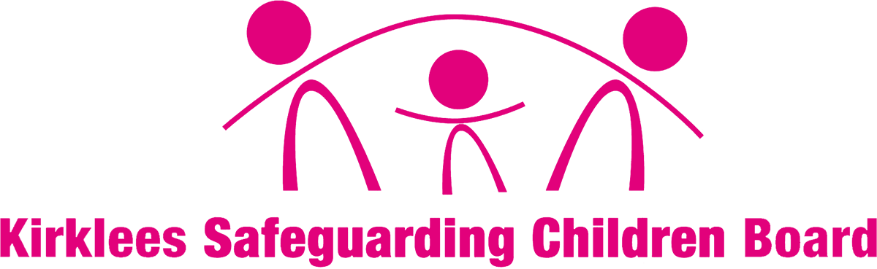

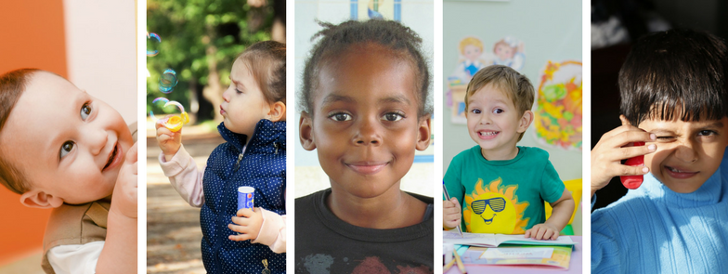

Kirklees Contextual
Safeguarding Strategy
2019-2021

Our Vision

Our vision for Kirklees is that people live in cohesive communities, feel safe and are protected from harm. That we provide high quality, joined up and accessible services which safeguard children and adults from harm.

This document provides the strategic framework to further develop and strengthen our response in the identification, assessment and intervention with child, young people and vulnerable adults.

Within Kirklees we want people to live in cohesive communities, feel safe and be protected from harm. This involves providing high quality, joined up and accessible services to safeguard children and vulnerable adults. We aim to make it clear that safeguarding is everyone’s responsibility, by joining up with partners including schools, to ensure children and adults have good access to well informed advice, support and decision making from across the partnership, and that service provide timely, proportionate and effective, responses when exploitation, abuse and harm occurs, ensuring a child/person centred approach.

2 Contextual Safeguarding

The world of Safeguarding is ever changing, becoming increasingly complex and is under intense scrutiny through the media, inspections, and inquiries. Child sexual exploitation, peer on peer violence, abuse, modern day slavery, harmful sexual behavior, and abuse including gangs and groups, criminal exploitation, and going missing from home or care, should not be seen in isolation as they often overlap , creating a complex set of harmful circumstances and experiences for children, young people, families and communities.

Contextual Safeguarding has been developed at the University of Bedfordshire over the past six years to inform policy and practice approaches to safeguarding adolescents. Initially emerging from a three-year review of operational responses to peer-on-peer abuse. Contextual Safeguarding provides a framework to advance child protection and safeguarding responses to a range of extra-familial risks that compromise the safety and welfare of young people.

“It is important that practitioners engage with individuals and sectors who do have influence over and within extra familial contexts, and recognise that assessment of, and intervention with, theses spaces are a critical part of safeguarding practices. Contextual Safeguarding, expands the objectives of child protection systems in recognition that young people are vulnerable to abuse in a range of social contexts.” (Firmin, 2017, University of Bedfordshire)

What is Contextual Safeguarding?

‘Contextual Safeguarding’ is an approach to understanding, and responding to, young people’s experiences of significant harm beyond their families. Traditional approaches to protecting children and young people from harm have focussed on the risk of violence and abuse from inside the home, usually from a parent and carer or other trusted adult and have not necessarily addressed the time that children/young people spend outside the home, the spaces they frequent, the influence of peers and young people’s safety in their relationships and environments.

Contextual Safeguarding recognises the impact of the public and social context on young people’s lives, and the interplay between different contexts and relationships and how they can impact on their safety. It recognises that the different relationships that children form with their peers and adults in their communities, schools and online can feature violence and abuse and that parents and carers may have little influence over these contexts, with the ‘weight of influence’ often being outside of the family. Whilst at the same time, young people’s experiences of extra-familial abuse can weaken parent-child relationships.

A Contextual Safeguarding approach seeks to identify and respond to harm and abuse posed to young people from either adults or other young people outside their home. It is an approach which focuses on how multi agency interventions can change processes and environments, working with young people and families to address the contexts of young people’s lives which can influence their behaviours and the ability of parents and carers to protect. It extends the focus of interventions from an individual child and their family, and in doing so, can make spaces safer for all young people

Child sexual exploitation, peer on peer violence, abuse, modern day slavery, harmful sexual behaviour, and abuse including gangs and groups, criminal exploitation, and going missing from home or care, should not be seen in isolation as they often overlap, creating a set of harmful circumstances and experiences for children, young people, families and communities.

During adolescence, peer relationships are increasingly influential and inform young people’s experiences, behaviours and choices. They often determine a child’s social norms and peer status. Peer group relationships are influenced by, the neighbourhood, the school, and online contexts in which they develop, and in turn shape these. (Figure 1).

If young people experience and socialise in, safe and protective neighbourhoods, schools and community settings, these will support them to form safe and protective peer relationships. Alternatively, if young people form friendships and relationships in contexts characterised by violence, abuse and/or harmful attitudes, which may also be anti-social, these may promote problematic social norms in those contexts and relationships; as a means for young people to navigate and /or survive in, those spaces.

Figure 1: Contexts of Adolescent Safety and Vulnerability (Firmin, 2013)

Working Together 2018 reflects the changing nature of child abuse, the required changes to the more traditional child safeguarding practice and provides an overview of why there is a need for agencies and partnerships to adopt a contextual safeguarding approach:

“As well as threats to the welfare of children from within their families, children may be vulnerable to abuse or exploitation from outside their families. These extra-familial threats might arise at school and other educational establishments, from within peer groups, or more widely from within the wider community and/or online. These threats can take a variety of different forms and children can be vulnerable to multiple threats, including: exploitation by criminal gangs and organised crime groups such as county lines; trafficking, online abuse; sexual exploitation and the influences of extremism leading to radicalisation.” (pg. 22)

3 The Local Context

Locally we have had a number of significant non recent investigations into the criminal and sexual exploitation of children, particularly young girls. In addition we have seen an increase in the affiliation of our children and young people to Urban Street Gangs and as a consequence, involvement in Organised Crime and criminal exploitation, particularly with regards to movement and supply of controlled drugs.

The strategy’s overall objective is focused on safeguarding young people from exploitation. It recognises that to do this effectively, a range of other vulnerabilities need to be better understood and interventions need to adapt, with partners, peers, families and communities being better placed to respond.

As young people get older their experiences of abuse are often associated with public environments in which they spend their time. As such, a critical focus of this strategy will be on how young people can be better protected and supported by a wider range of individuals and services in a wider variety of contexts. This will include ensuring we enable young people to engage with these services when they need them.

Widening the strategic scope reflects the fact that young people often face multiple risks. Dealing with the response to certain threats in isolation can potentially hinder the understanding of vulnerabilities that frequently overlap and hence limit the effectiveness of intervention. We are committed to seeing the child in the context of their lives not simply in the context of the current vulnerability or harm they have suffered or are exposed to.

We are committed to ensuring that collectively we safeguard our children and young people from exploitation and work continues at pace to develop a comprehensive partnership approach to Contextual Safeguarding coordinated through the Multi-Agency Risk and Vulnerability Hub. We recognise that it is those children, young people and vulnerable adults that have multiple vulnerabilities who are most likely to be sexually and /or criminally exploited.

In order to do this effectively, children and young people need to be seen, heard and supported:

- Seen: in the context of their lives at home, friendship circles, health, education and public spaces (including social media).

- Heard: to effectively protect children and young people, professionals need to take time to hear what children are saying and put themselves in the child or young person’s shoes and think about what their life might truly be like.

- Supported: by remaining professionally curious and by implementing effective and imaginative solutions that help children and young people.

Child exploitation by any individual, or group of individuals who come together in person or online for the purpose of setting up, coordinating and or taking part in the exploitation of children and young people, in either an opportunistic way or organized and will always be a priority for the Kirklees Safeguarding Partnership.

4 Strategic Aim and Objectives

This aim of this strategy is to support Kirklees Safeguarding Partners to work more effectively together, through intelligence gathering and analysis, common working arrangements, and joint learning and development opportunities.

The strategy outlines the Kirklees approach to:-

- Prevention, early identification, and support for children and young people, vulnerable adults, families and communities.
- Disruption, diversion and prosecution of individuals or groups who seek to facilitate and/or exploit, abuse and harm children and young people.
- Identification of locations where exploitation and abuse is perpetrated and action to make these places safe spaces.

Our Strategic Objectives are:-

Objective 1 Prepare
To develop a comprehensive and accurate intelligence picture which will inform local partnership understanding, and enable swift coordinated multi-agency responses to safeguard children and prevent, divert or prosecute those who seek to facilitate and /or perpetrate the exploitation, abuse and harm of children and young people.

Objective 2 Protect
To develop effective practice and service provision to protect children, young people, vulnerable adults, families and communities, and ensure positive outcomes for all, whilst empowering individuals building resilient communities.

Objective 3 Prevent
To prevent children , young people and vulnerable adults experiencing or continuing to experience, exploitation, harm and abuse by responding to, information and intelligence that identifies individuals, groups or locations of concern, and highlights patterns or trends.

Objective 4 Pursue
Use information intelligently to prosecute those who seek to facilitate and /or perpetrate the exploitation, abuse and harm of children, young people and vulnerable adults, and ensure that a holistic, person centered approach, from intervention, to where necessary prosecution, is adopted and employed.

5 Partnership Commitment and Governance Arrangements.

To achieve the strategic aims and objectives, we will:

- Influence and inform the development of the Kirklees Safeguarding Children multi-agency procedures, protocols, and practice guidance. Taking account of new legislation, national and local research, and policy, guidance, and inspection frameworks.

- Ensure that the Kirklees Contextual Safeguarding Strategic Group is appropriately resourced to implement the strategy.

- Ensure that the Kirklees Contextual Safeguarding Operational Group is appropriately resourced to deliver against the action plan.

- Ensure that progress of the Kirklees Contextual Safeguarding Strategy and Action Plan is driven by the Chair of the Kirklees Contextual Safeguarding Strategic Group, with the Kirklees Safeguarding Children Partnership providing oversight and accountability.

- Develop our relationships with Kirklees Safeguarding Children Partnerships Multi-Agency Arrangements, Community Safety Partnerships and Safeguarding Adult Boards, to maximize opportunities for learning and development.

- Ensure that Lead Officers commit to, support and deliver the work of the Kirklees Contextual Safeguarding Strategic and Operational Groups.

6 Governance
Children & Young People’s Partnership Board

KSCB-Safeguarding Partnership

Contextual Safeguarding Strategic Group

Contextual Safeguarding Operational Group

MACE (to be renamed)

7 Terms of Reference

Children and Young People’s Partnership Board
Insert TOR and membership

Contextual Safeguarding Strategic Group
- Contribute and work in accordance with the Board's Business Plan to drive forward the work on risk and vulnerability, and ensure effective cooperation between agencies and professionals.
- To develop/review the implementation of contextual safeguarding strategy and action plan in conjunction with the West Yorkshire Policies and Procedures Group
- To collate and analyse data and identify any patterns, trends and issues in relation to risk and vulnerability.
- To identify training requirements concerning risk and vulnerability ensuring that staff are adequately trained in how to identify and respond to risk and vulnerability, and support practice development activities.
- To develop local strategies to address risk and vulnerability in conjunction with the regional contextual safeguarding steering group.
- To ensure effective links are established with safeguarding in schools, Learning and Development work stream, Community safety partnership and other relevant groups.
- To provide update reports to the Development and Business Planning Group highlighting work plan progress and challenges.
- The workstream will be composed of managers nominated by each of the member agencies and other relevant local agencies or organisations.
- The Chair will be a Board member.
- The Work Stream will meet quarterly to discuss risk and vulnerability.

Accountability

The Contextual Safeguarding Strategic Group are accountable to the KSCB and will report to the Board through the Chair of the Workstream. The Chair will provide update reports to the Development and Business Planning Group, highlighting work plan progress and any problems encountered with implementing actions.

Individual members take responsibility for reporting through and to their own organisation. If members are unable to attend meetings for any reason they should send, a nominated representative.

Membership (This section will need amending)

Chair of work stream (Board Member) | Kirklees CSC CPRU | Police
KSCB Coordinator and BSO | CGL (the Base) | Education including Further Education
Education Safeguarding Team | Kirkgate Buildings | Voluntary/Community/Faith
Adult Social Care and Safeguarding | YOT | Probation
CSE Hub Team (CSC and Barnardo’s) | SWYFT | CHFT
Children Social Care | LOCALA | KNH
CCG | Safe and Cohesive Community | Mid Yorkshire NHS Trust
Lay member | Licencing | EITS

Contextual Safeguarding Operational Group

The Contextual Safeguarding Operational Group is the multi-agency operational working group which reports to the Contextual Safeguarding Strategic group via the Kirklees Safeguarding Children Board.

Its purpose is to:-

- Action and drive the implementation of the KSCB CSE and Missing action Risk and Vulnerability plan.
- Develop and monitor performance management data and feed into Performance Intelligence and Policy work stream.
- Audit process via the Performance Intelligence and Policy work stream.
- Collate and analyse data and identify any patterns, trends and issues in relation to Child exploitation and Children Missing from Home, Care & Education.

- Develop and identify potential commissioning of services for children, young people families and communities relating to child exploitation and missing children.
- Identify improvements to service delivery for partnership working to improve our response for children to transition into adult services.
- Ensure effective joint working across all statutory partners including voluntary, community and faith sector providers.
- Identify training requirements concerning child exploitation and missing children. Develop a standard training pack for all organisations with bespoke for specialisms.

- Organisations to evidence what they have achieved on a continuous basis when requested.

- Ensure a practical multi agency partnership approach which focuses on Prepare. Protection, Prevention and the Pursuance of offenders.
- Have an approach that reflects a shared understanding of operational issues.
- Identify improvements to service delivery for partnership working to improve our response to child exploitation and Missing children
- To ensure the established ‘MACE’ arrangements work effectively ( name to be changed)

Accountability

Group members are expected to represent their organisation, if they are unable to attend a substitute colleague should attend on their behalf. Actions should be are communicated and implemented across individual organisations. Evidence of actions to be supplied to the KSCB Business Support Officer two weeks prior to each operational meeting. KSCB.admin@kirklees.gov.uk

Membership

KSCB Board Manager and BSO | Education Safeguarding Team | Police
Children’s Social care | Adult Social Care | Education
CGL (the Base) | Brunswick Centre | LOCALA - LAC Nurse, Sexual Health representative, Safeguarding Specialist Practitioner, Outreach and Intervention Service
Voluntary/Community/Faith | Probation | Community Rehabilitation company
Youth Offending Team | South West Yorkshire Partnership Foundation Trust | NK and GH Clinical Commissioning Group
Safer Kirklees | Kirklees Neighbourhood Housing | Kirklees Public Protection /Licensing and Environment
.
Chair

Contextual Safeguarding Operational group will be co-chaired by the Police and Children’s Social Care, Deputy chair to be agreed?

Management and administration

Kirklees Safeguarding Children Board will provide administrative support to the group.

Frequency of meetings

The Operational Group will meet every 2 months in advance of the Strategic group meetings.

Multi-Agency Child Exploitation (MACE) Group

Insert TOR and membership
References

- https://contextualsafeguarding.org.uk/assets/documents/Contextual-Safeguarding-Briefing.pdf
- Firmin 2013, https://contextualsafeguarding.org.uk/assets/documents/Contextual-Safeguarding-Briefing.pdf

- https://www.gov.uk/government/publications/working-together-to-safeguard-children--2

